**Rule Discovery Using EODNet for Image Classification**

*Submitted in partial fulfillment of the requirements for the degree of*

Bachelor of Technology

in

**Computer Science and Engineering**

*by*

## SUBHADITYA MUKHERJEE

**Under the guidance of Prof. / Dr. Vijayarajan V**

**Computer Science and Engineering**

#### VIT, Vellore.



May, 2021

**DECLARATION**

I hereby declare that the thesis entitled “Rule Discovery Using EODNet for Image Classification " submitted by me, for the award of the degree of *Bachelor of Technology in Computer Science and Engineering* to VIT is a record of bonafide work carried out by me under the supervision of Vijayarajan V.

I further declare that the work reported in this thesis has not been submitted and will not be submitted, either in part or in full, for the award of any other degree or diploma in this institute or any other institute or university.

Place : Vellore Date :6/6/21

#### Signature of the Candidate

**CERTIFICATE**

This is to certify that the thesis entitled “Rule Discovery Using EODNet for Image Classification” submitted by SUBHADITYA MUKHERJEE **& 17BCE2193**, VIT, for the award of the degree of *Bachelor of Technology in Computer Science and Engineering*, is a record of bonafide work carried out by him / her under my supervision during the period, 01. 12. 2018 to 30.04.2019, as per the VIT code of academic and research ethics.

The contents of this report have not been submitted and will not be submitted either in part or in full, for the award of any other degree or diploma in this institute or any other institute or university. The thesis fulfills the requirements and regulations of the University and in my opinion meets the necessary standards for submission.

Place : Vellore

Date : **Signature of the Guide**

#### Internal Examiner External Examiner

Head of the Department Programme

## ACKNOWLEDGEMENTS

#### Student Name

# Executive Summary

Summary of the thesis

One page and not exceeding 200 words Times New Roman, 12

**CONTENTS Page**

**No.**

#### Acknowledgement i

Executive Summary ii

Table of Contents Iii

List of Figures ix

List of Tables xiv

Abbreviations xvi

Symbols and Notations xix

1. INTRODUCTION 1
   1. Objective 1
   2. Motivation 2
   3. Background 3
2. PROJECT DESCRIPTION AND GOALS 3
3. TECHNICAL SPECIFICATION 3
4. **DESIGN APPROACH AND DETAILS (as applicable)** .
   1. Design Approach / Materials & Methods .
   2. Codes and Standards .
   3. Constraints, Alternatives and Tradeoffs .

#### SCHEDULE, TASKS AND MILESTONES .

1. **PROJECT DEMONSTRATION AND CODES** .
2. **COST ANALYSIS / RESULT & DISCUSSION (as applicable)** .

|  |  |  |
| --- | --- | --- |
| 8 | **SUMMARY** | . |
| 9 | **REFERENCES** | . |
|  | **APPENDIX A** | . |

**List of Figures**

|  |  |  |  |
| --- | --- | --- | --- |
| **Figure No.** |  | **Title** | **Page No.** |
| 2.1 | Figure caption |  | 13 |
| 2.2 | Figure caption |  | 15 |

(In the chapters, figure caption should come below the figure and table caption should come above the table. Figure and table captions should be of font size 10.)

### List of Tables

**Table No. Title Page No.**

2.1 Table caption 28

## List of Abbreviations

3GPP Third Generation Partnership Project

2G Second Generation

3G Third Generation

4G Fourth Generation

AWGN Additive White Gaussian Noise

## Symbols and Notations

f CFO

 NCFO

### INTRODUCTION

* 1. OBJECTIVE

The aim is to come up with EODNet : Efficient ODE Net as the novel architecture which takes the concepts of efficient neural networks and combines them with neural ODEs to generalize better to newer tasks. We use Neural ODE’s to replace Resnet blocks in order to get more optimal results with better performance matrix and better memory efficiency. Neural ODE solvers using Deep learning have been implemented to solve complex dataset that require classification problems and obtain optimal results. The primary goal is to obtain a higher accuracy using Neural ODE solvers on the test dataset than normal ResNet networks or using Classification models.

* 1. MOTIVATION

In any field, data modeling is an extremely important factor in understanding a system. In classical cases, Ordinary differential equations were used to perform this discovery. A recent paper [1] merged the concepts of ODEs with Deep learning and created a neural ODE in which a ResNet architecture’s res-blocks were substituted with an ODE solver which led to not only better results, but also more memory efficiency. This project aims to attempt to come up with a better architecture that gives SOTA results on different datasets. The datasets that have been used are ASL dataset, Boat type recognition dataset, Flower recognition dataset, Fruits 360 dataset.

* 1. BACKGROUND

The concept of Neural Networks has been used in approximation of bounded continuous functions in the field of Machine Learning. Neural Networks are algorithms that recognize relationships among complex datasets to identify patterns and complete tasks. Neural Networks have been efficient in solving time series data and NLP problems. These networks provide various frameworks and procedures for solving ODE and PDE in a numerical manner. ODE is referred to as Ordinary Differential Equation which consist of one or multiple functions of an independent variable and the derivatives of the function in the equation. Neural ODE solvers have been instrumental for solving complex equations containing various functions of variables and have performed better than normal ResNets in terms of various parameters. They are more memory efficient and computationally adaptive. Both speed of solving equations and the accuracy of results can be balanced. Parameter efficiency is said to be better in Neural ODE solvers.

1. **PROJECT DESCRIPTION AND GOALS**

This project is a research attempt into ODEs and combining them with neural networks to form neural ODEs. A novel architecture is proposed that combines a EfficientNet b5 backbone customized with a Neural ODE structure. This allows for more explainability and further efficiency. The ideas are applied to the task of ASL recognition, Boat type recognition dataset, Flower type recognition dataset and for detecting fruits dataset. Accurate results are aimed for with better efficiency and memory.

Fig 1: ASL dataset

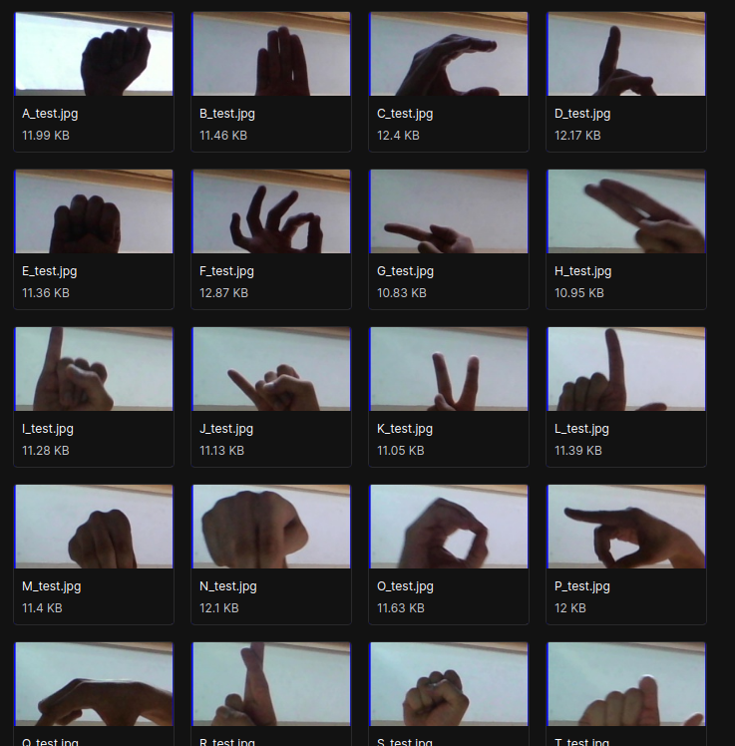

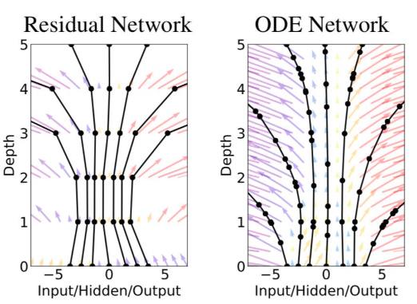Fig 2: ODE flow

Neural Networks are important for the approximation of bounded continuous functions in the field of Machine Learning. Such networks provide various frameworks and procedures for solving ODEâ and PDEâs in a numerical manner. The paper [9] discusses about the use of a solver for ODEâs and PDEâs using Neural Network frameworks. Such Neural Networks use function approximation for performing the tasks. The solver has proven to show high accuracy for both initial value problems and boundary value problems.it works for the functions as well as the derivatives. The solver is tested using collocation points using the Burgers equation and the heat equations. The ODE solver works well for the ODEâs and shows great accuracy. Boundary value problems are challenging to solve using the equation mentioned and another drawback is the computational efficiency of the ODE solver. Accuracy must be improved in the case of boundary value problems.

Stochastic gradient for a given ResNet neural network is made to converge to the stochastic gradient descent for a Neural ODE. All the layers in the ResNet neural network share the same weighted matrix. It proves that Neural ODEâs are the deep limit of such neural networks. Several equations have been tried and the result has been obtained using the Fokker-Plank equationsâ equation and theorems resulted in a large number of convergence results. Convergence rates are high and are optimal for the results. It only considered the convergence of minimizers and not the optimization procedure. Regularization cannot solely explain the numerical simulation.

The use of DiffEqFlux library is described and an explanation for how it is used for solving several ODEâs and other type of differential equations is given. All the ODEâs are taken as a flux defined neural network. The purpose of using the DiffEqFlux library is to solve such ODEâs where simple integration strategies are not sufficient to get optimal results and solutions with high accuracy. The ODEâs are defined as neural networks and proper description of the Flux model zoo is provided that includes neural stochastic differential equations. The library helps in developing highly accurate ODE solvers that can play a major role in various applications of Machine Learning and Data Science. Various architectures of Deep Learning have now been considered as Neural ODEâs. It helps bring closer the gap between deep learning and systems that are dynamic in nature.

The major challenges faced are figuring out the working of the models and the dynamics associated with them. The design choices for building the modules have to be elucidiated.The framework is set up for building a general Neural ODE and the components associated with it are considered. Infinite dimensional problem has been solved using numerical approximations that lead to better models for solving ODEâs. There are a variety of linear Ordinary differential equations that exist today for which various methods exist to solve them. The paper[3] discusses about the multiquadric radial basis function networks and its use in solving linear ODEâs in an efficient manner. By approximating functions and its derivatives using radial basis function networks, another RBFN is formed which can be efficient in solving Linear ODEâs with better accuracy. It is the most optimal method to determine the existing parameters. It fixes the problem of not having enough data samples as it deals with only the domain and the existing boundaries associated with it.The method can be used to solve even PDEâs.A sample set is selected from the training set and positions of centers of basis functions are selected-means clustering algorithm is used on the training set and the centers of the clusters are used as the centers of the basis functions. It is useful for large-scale problems that exist in several engineering fields.The major challenge faced by this approach is that the number of basis fucntions and data set must be provided with a priori. Function approximation has always been an unstable task when it comes to using differential equations.

The challenge of achieving a stable flow and also having a low computational cost has been tackled by the authors[8]. The techniques proposed in this paper use an energy function to guarantee the asymptomatic stability of the solution. Every deep learning algorithm is function composition between an input and an output space and is basically a mapping between them. This process was known but a proper optimization process was not identified so far. This paper proposes an algorithm to reduce the instability and stiffness that a solver might face by using a parametrized energy function. This takes care of of the floor of the network States and moves it along the negative gradient. Instead of trying to learn a single function, the algorithm tries to learn functions from the function space. There are -3- multiple types of models that are possible and observed. Autonomous port Hamiltonian model, second order and stochastic models are also defined. In training the model smooth scaler cost function was used to understand how well the model performs and also to minimize the loss in an optimal setting.

The computing of gradients is is efficient with respect to to the choice of the parameters. To ensure that the energy function remains steady, a soft constraint was also added. Neural network architectures are composed of states as well as hidden layers. Using this concept, it is possible to understand the mapping between the vector spaces of the input and outputs. We can further take this idea and replace the entire component of the hidden states by using a differential equation solver. And framing the network problem as an ODE problem. This is the premise of a paper by Chen et al. The major advantage of using models success this is the near constant memory costs as well as a higher customization by means of allowance for trade off between speed as well as precision values. The second advantage is that of huge boost in efficiency due to the process of back propagation not being required as a differential equation solver is being used instead. This also leads to pretty high guarantees about stagnating errors as well as the ability to be trained using the maximum likelihood model.It is also possible to to train on data that is not static and arrives non concurrently due to its nature. The method used to solve the equations makes use of the calculation of a secondary equation backwards which allows for efficiency in memory as well as the ability to define the error threshold. These benefits do not generally come with standard deep learning models. Making use of this black box idea, the authors replace the standard ResNet models with an architecture that uses the solver instead of hidden layers. The only issue is that the analogue to the depth of a network cannot be obtained in this scenario.

The model RK-Net performs similar to the original ResNet on the MNIST dataset and many others as described in the paper. Using a solver also allows the model to have multiple hidden units without affecting the time complexity of the training. Being able to discover new equations using data has always been a dream when it comes to the field of computer science. There is the possibility of harnessing deep learning for the same by augmenting the capabilities of scientific modeling. This leads to the creation of an UDE which would potentially enable the user to extrapolate factors that do not exist in the data as well as be able to simulate better models more accurately. Using the principles of physics, it is also possible to incorporate the existing knowledge into the network. The combination of differential equations in an ML concept to create a PINN using the UAT has also been shown.

It demonstrates the ability to obtain the equations that define a system using just data and also the possibility of recovering an equation from the time series data to extrapolate it. It also talks about the possibility of using the physics laws of conservation to to identify new systems by means of transferring previous knowledge. The approach of using physics and form networks allows the creation of solvers that can efficiently create gradient related calculations that are required to to perform any kind of machine learning task. Even though the existence of residual networks have been present for a long time the technique for or constructing such models for a continuous and invertible function was not present. This paper shows how to prove any homeomorphism that can be approximated by using a combination of neural networks and ODEs in Euclidean space. This leads to the ability of using residual connections and blocks to create a reverse mapping between the output space as well as input space and allow for applications such as deep learning-oriented ones.

The major challenges faced by most of the normal approaches are that the number of basis functions and data set must be provided with a priorate convergence functions are also not well defined and are mostly based on the dataset for performing computations. For ResNet architectures, the depth of the network cannot be accurately determined. The further challenges faced by the Neural ODE’s used are that they cannot be compressed into dynamic Neural Networks very easily and fitting time series datasets with high efficiency. In terms of computation, memory required can be high with larger computational times due to large number of layers and not a fixed architecture. In the architecture developed for our system these factors are tackled and solved. Neural ODE solvers with Deep Learning helps solve complex classification problems and improve computational speeds. Compared to a normal Residual network, the depth and the flow of parameters in an ODE network are much smoother and more predictable which makes it easier to understand decisions mathematically.

The dataset that will used for the ASL detection https://www.kaggle.com/grassknoted/asl-alphabet. This has about 29 classes of which, 10 classes will initially be used to test the system. This will be done using pandas and a data frame will be created from the dataset to allow for easier processing. Stratify will also be used to ensure that the classes remain the same count while sending it to the training loop. Data preprocessing is done on the dataset, data is then transformed and then the right model is evaluated for testing on the dataset After the dataset training is done, the Neural ODE solvers are used on the test dataset to classify the ASL images and detect the right symbol.

Fig 3: ASL dataset example

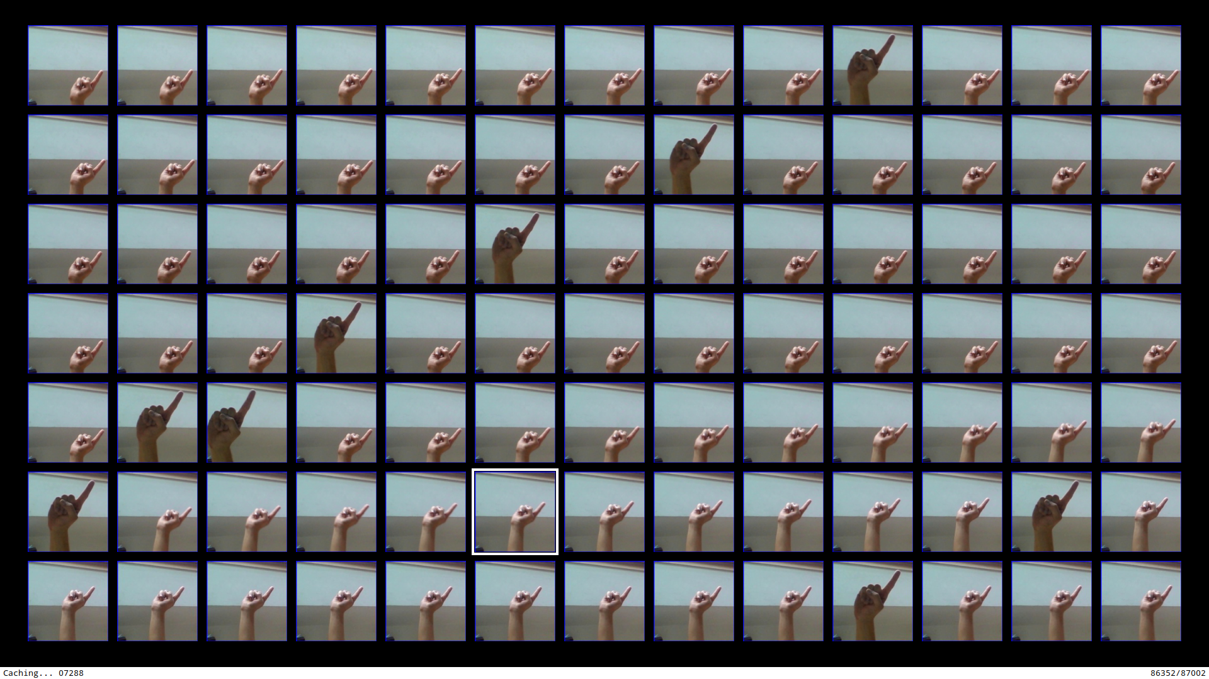

For the dataset of boat type recognition https://www.kaggle.com/clorichel/boat-types-recognition, there are about 1500 images of boats including parameters such as sizes, shapes but classification is done on the basis of different types of boats. Such boats involve buoy, cruises, ferries, kayaks and others. The aim used to use our Neural ODE architecture and implement a memory efficient model to detect the type of boat.

Fig 4: Boat dataset example



For the flower recognition dataset, there are 4242 different images that are included in the dataset. The data is collected using different websites. The main objective of using this dataset is to identify plant species from a given picture. The dataset has five classes of flowers. There are 800 pictures in each class. The resolution of the pictures are 320 x 240 pixels. Every photos have a different proportion.

Fig 5: Flower dataset example

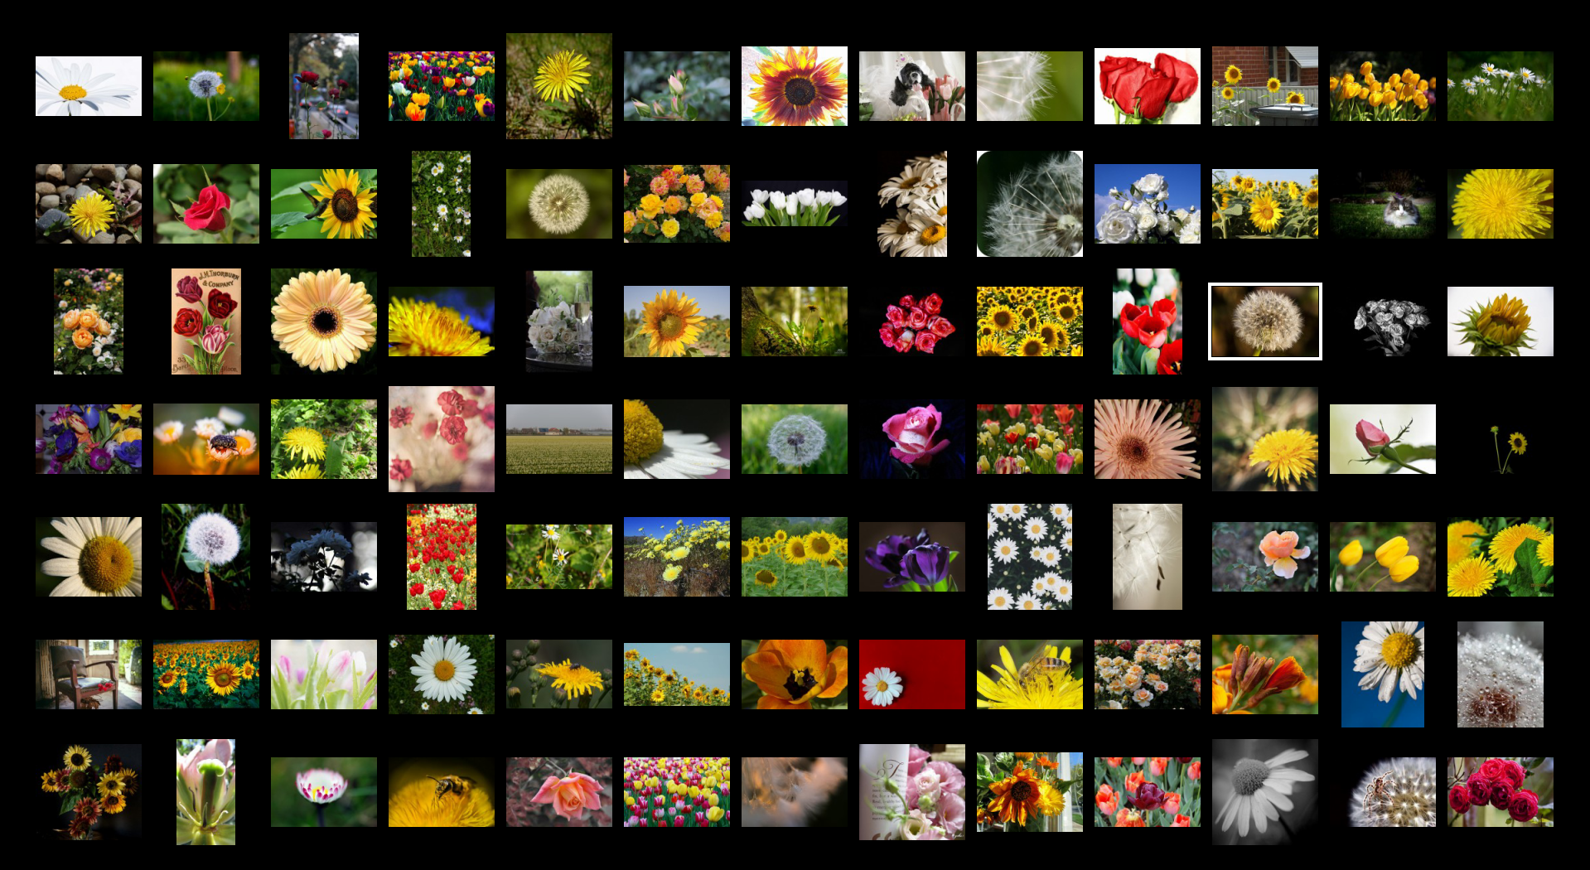

For the dataset containing images of garbage, there about 15150 images and the training dataset has 12120 images. The test dataset has 3030 images. The total number of classes are 12.

Fig 6: Garbage dataset example

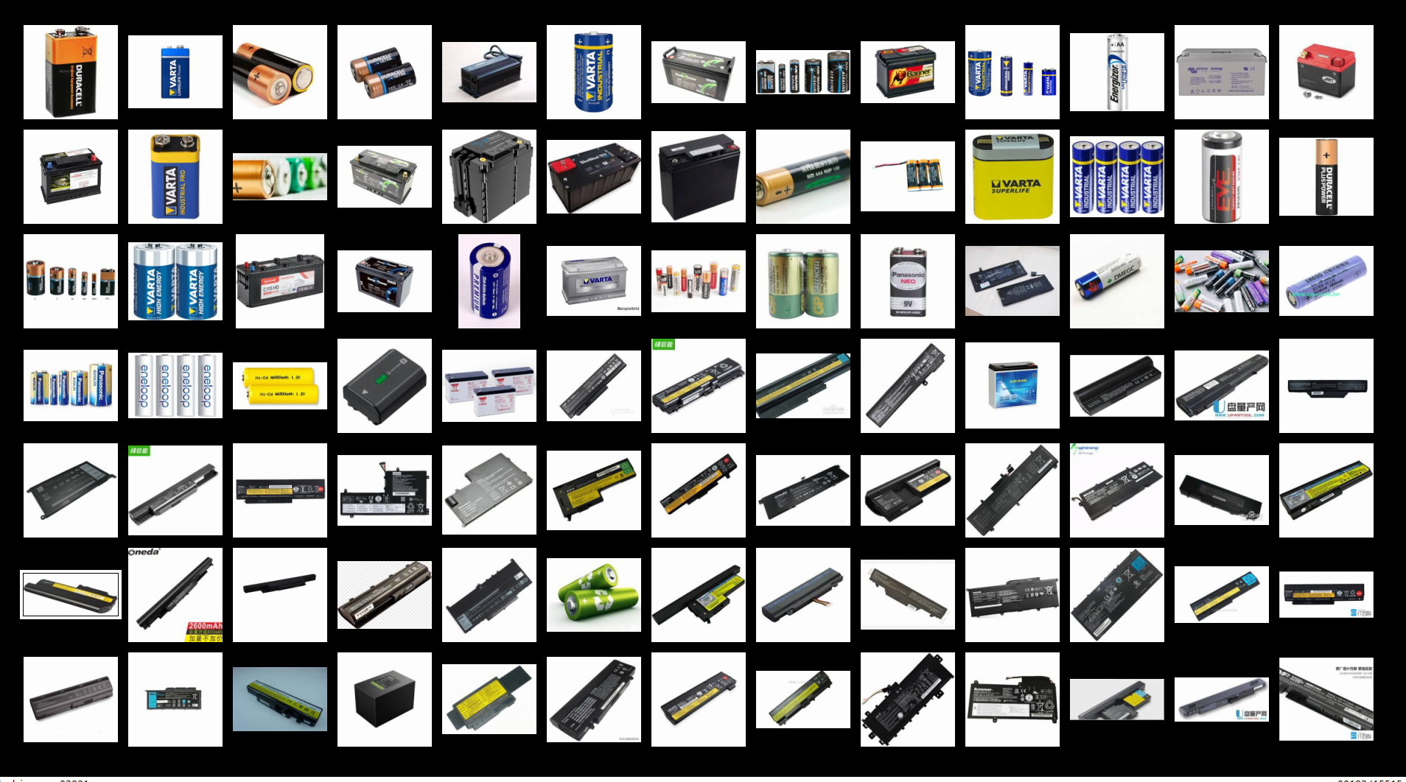

For the dataset containing images of fruits, there about 90483 images and the training dataset has 67692 images. The test dataset has 22688 images. The total number of classes are 131 and each picture has a size of 100 x 100 pixels.

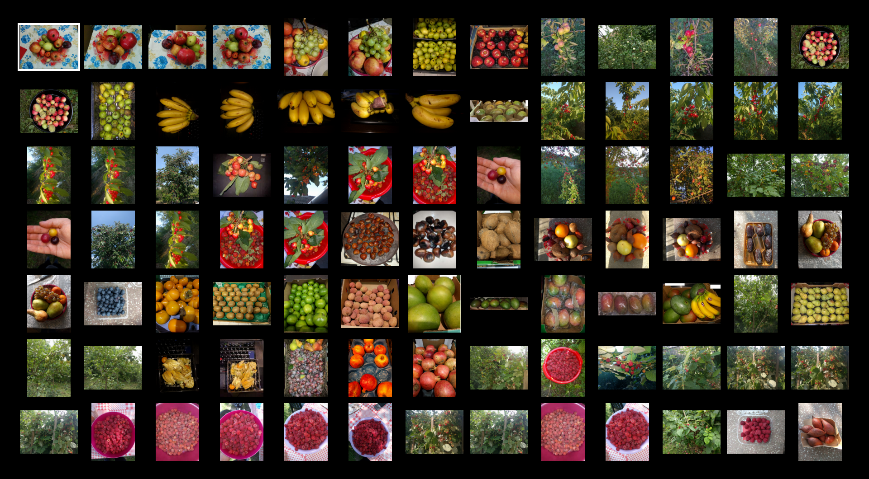

The aim used to use our Neural ODE architecture and implement a memory efficient model to perform classification on these datasets. Using the Neural ODE solver and the architecture, a far better accuracy is obtained on the test dataset.

The first part of the project will involve going through multiple papers and doing a comprehensive survey of the work that is already there. The objective is to identify which architectures are being used and possibly what memory requirements they come with in comparison to their non ODE counterparts. Standard metrics will be used to compare the architectures and possibly other metrics to identify how well the architectures generalize.

The second part of the project will involve testing multiple architectures on classification tasks and coming up with one that does better on a variety of these tasks and is more suited to being used with an ODE solver. We will start with a standard ResNet architecture and then branch out to similar ones. Since this is a relatively new paper, there are many architectures that have not been worked on and those will be targeted first. The insights from these will be used to come up with a better architecture and find out what influences it.

The simplest way to explain the workings of the model is as follows. Every neural network aims to map one feature space to another, namely the input space to the output feature space. This mapping is generally solved by our artificial neurons. In most cases, that does a very good job. But it is not explainable nor can be directly understood by humans, that makes it entirely a blackbox. ODEs on the other hand can be solved and proved at every point that it gives results for. Since we can combine both, we can take the power of neural networks and add the power of neural ODEs to it for maximum benefit.

There are many tricks that were used in this project to make use of recent research and the most useful techniques. These were all chosen from SOTA papers. The first was stratifying the data to ensure that the total number of classes while training does not influence the outcome. It basically involves using sampling to scale the number of classes so that the data loader gets an equal distribution of each class.

The second trick used was learning rate scheduling which basically involves using multiple changing learning rates throughout the training process. This is done in contrast with other methods that require a fixed single learning rate and essentially improves training.

The third was a change in optimizers, instead of using RMSProp or ADAM, we use ADAMW which is a new optimizer that relies on finding learning rates dynamically.

Other important things to mention is that we are using transfer learning. This would reduce our training time drastically. Since our network is a custom one, we can only load the weights for the EfficientNet backbone and the rest of the network cannot have pretrained weights since we just created it.

All these come together to provide better training.

1. **TECHNICAL SPECIFICATION**

Functional Requirements

Functional requirements are defined as any kind of requirement that is essential for the system and outlines the major features that would be required at the end as well as the limitations, assumptions and perspective of the end user.

Product features

Being a research project, the features of this project are in development. The objective is to create a system able to identify American sign language from images without requiring any specialised hardware in near real time.

The system would be able to take images using a camera and predict which letter of the alphabet the end user is showing. This code could be used to predict what the end user is saying and output words by combining letters.

The novelty of the feature is a system using a newer approach which is more explainable in the long run compared to just using a traditional deep learning network.

User characteristics

The users can be of two categories. The first being someone who cannot speak properly and uses ASL to communicate. This category is the main target group. It is assumed that they have access to a phone and can see and interact with a simple system if required.

The second type of user category includes people who want to understand what someone else is saying. They will be more familiar with a point and identify type of system.

The central purpose of both the users are the same and there will not be much difference between their interfaces.

Assumption & Dependencies

The system is dependant on the availibility of a phone/computer with a camera. It also requires a minimum CPU for inference along with the capability to run inference from any neural network.

There was a single assumption that was made to simplify the use case. It was assumed that the users taking part would be able to see. Future development may include a voice interface but for now that will not be worked on.

Domain Requirements

The domain in which our system falls is social understanding. This would require a moderate amount of accuracy and a way of ensuring that the predictions are accurate and unbiased. It would also require explainability which is ensured by the addition of the neural ODE.

User Requirements

The user would require an interface that would allow for a camera input and then have a separate screen for inference. This inference would include some sort of sentences that the user has captured using the app from the person using sign language.

The user would also require an accurate application as the absence of accuracy would bring about challenges in communication.

-Functional Requirements

Product Requirements

Efficiency (in terms of Time and Space)

The inference takes place in constant time and time and space complexity varies as per the training of the dataset. Test dataset computation is performed accordingly and the efficiency and complexity are determined.

Reliability

It can detect the sign language successfully at the end of the test dataset. The user can identify the correct sign language used and the meaning of it. The results are accurate and the Neural ODE solvers compute the task in less memory space and faster execution time.

Portability

It can be used in various systems and interfaces. Any system with a functioning camera and GPU can run the software and use it. The Sign language detector accurately gives results in all such systems

Usability

Users can use the software with ease if there is a camera and good GPU in the system. The interface is easy to navigate and the user can use the Sign language detector very easily. It gives a very accurate result and helps in communication with people that need sign language to communicate with others. It gives users a detailed view of the sign language system and how it works in classifying sign language symbols and showing the result.

Organizational Requirements

Implementation Requirements (in terms of deployment)

There should a functioning camera and a GPU present. Python libraries and JupyterLabs are used for training the dataset and running the code. The dataset that will be used is the ASL dataset from https://www.kaggle.com/grassknoted/asl-alphabet. This has about 29 classes of which, 10 classes will initially be used to test the system. This will be done using pandas and a data frame will be created from the dataset to allow for easier processing. Stratify will also be used to ensure that the classes remain the same count while sending it to the training loop. Data preprocessing is done on the dataset, data is then transformed and then the right model is evaluated for testing on the dataset After the dataset training is done, the Neural ODE solvers are used on the test dataset to classify the ASL images and detect the right symbol.

Engineering Standard Requirements

The primary requirement is identified which is need of classification of symbols of the ASL dataset. System planning takes place where all the user requirements and functionalities of the program is discussed. System specification and conceptual review is done to determine how the classification will be done using the Neural ODE solvers and recognize symbols of the ASL dataset. User flow and navigation is determined and implemented. Once the dataset is imported, data is sorted and transformed for the training of dataset to begin. The dataset is split into train and test data. Neural ODE solvers work on these classes of data for classification problem. System operational requirements are noted and implemented accordingly. Maintenance work is done for the right model evaluation and improving the training time and parameter tuning to achieve results with faster execution speeds and high efficiency. After all the analysis is done and requirements are defined, the system is developed and functionalities are implemented.

Operational Requirements

The ASL classifier that is solved by Neural ODE can have a great economic impact on the industry that is trying to help the handicapped people and people who only use sign language to communicate. The software can help such section of the society and they can communicate with normal people as well much more easily and faster. The usability and portability of the software can help bolster the emerging technologies that aim to help such sections of the society. It is of great social assistance and plays a pivotal role in making communication with them easier and promote better social culture and harmony. More people can interact with those that use sign language for communication. It serves ethical purposes as well and is very much sustainable for long term use.

System Requirements

H/W Requirements

● Intel i7-7700HQ 2.80GHz

● 16 Gb RAM The specifications of the GPU is as follows

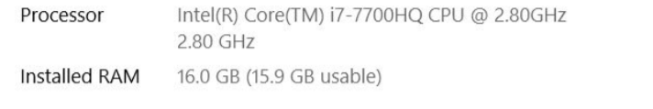

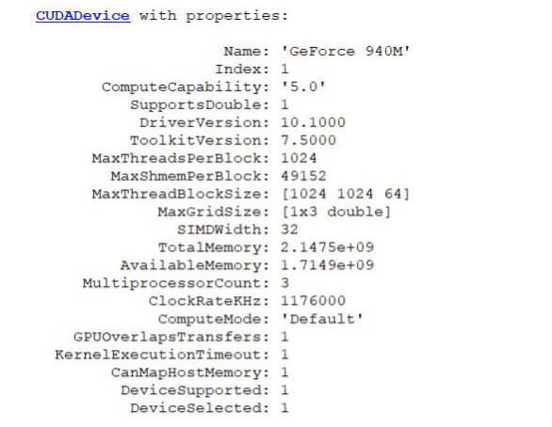

S/W Requirements

* numpy
* matplotlib
* pytorch
* pytorch lightning
* torchdiffeq
* JupyterLabs
* Albumentation

1. **DESIGN APPROACH AND DETAILS**

4.1 Design Approach / Materials & Methods

The aim is to come up with EODNet: Efficient ODE Net as the novel architecture

which takes the concepts of efficient neural networks and combines them with neural ODEs to generalize better to newer tasks.

ConvNets are often designed for fixed resources but if higher accuracy is achievable for a given system, then more resources are added. One of the main ways to enhance performance are by balancing the width, depth and resolution of the network. An uniformity needs to be maintained in the system for it to be achievable. It is done by developing a compound coefficient. It has 6.1 faster speeds than a normal ResNet architecture and much better accuracy and performance is achieved. A challenge faced by previous ConvNets were that extensive tuning was required in order to scale the dimensions. One way of solving this issue is by scaling the dimensions of the given network system using a constant ratio. In such a way uniformity is maintained in the network. Increasing the depth of the network leads to utilization of more resources and improves computational speeds.

For a given dataset, it depends on the size and dimension of the data and images. If the size is large, then more layers are needed in the network to improve efficiency and obtained fine patterns. The deeper the ConvNets are, the more complex features it can capture and perform tasks. It is however difficult to train such deep networks. The preferred scenario would be to scale width, depth and resolution appropriately. The more width the network has, the harder it is to train that network. Grid Search is used to find the most suitable and best solution. Wide network systems are easier to train but sometimes if they are too wide, some high-level features are not captured properly. Accuracy of models that are big are lesser as it flattens out the effects of scaling models for bigger models. For higher accuracy, all dimensions of the network must be balanced during scaling.

In the NIPS 2018 conference, the idea of substituting Residual networks with ODE solvers was first introduced. Here we first try to understand what this actually means and why it works the way it does.

In layman’s terms, an ODE solver aims to solve the initial value problem and identify the dynamics of a system given a set of data points. This is very widely used in solving physics problems such as fluid movement or fuel combustion calculations. The simplest version of these is the Euler method which basically takes a bunch of points as input and attempts to come up with an ideal representation of the data. In computer systems, this is ideally done using chaining. And ODE solvers have been around for a long time which do the same. When it comes to large number of data points, especially as in the data for a neural network system, batching becomes essential. Since this is not very trivial as a solution, a vectorized mapping is used to perform the required operations.

Now when it comes to a neural network, it is known that they are just mapping an input to an output vector space. A special type of network called the residual network thus can be used to do the same and to a large extent, since they share similar properties, can be further approximated by a ODE solver. There are many advantages of using this hybrid network over just a pure neural network solution. Some of them are:

The ode solver uses what is called adjoint sensitivity. It is a technique where every point in predicted trajectory of the solution represents a point of differentiation. Thus they are similar methods. This allows to understand the outputs much better and also helps with explainability to a large extent.

The second useful property is that using an ODE solver, we can prioritize either speed or precision and even choose how much of each we require. This is extremely useful when training large networks.

Another advantage lies in the ability to solve for continuous time series as well as time steps with missing values. This is not very easily solved by a regular neural network. Something like 3D point solving can also be done much easier using these networks.

Thus, almost any function that is tractable, differentiable and parametric can be approximated using this method.

Of course, it can be argued that a neural network can learn any function. That is true, but a standard neural network is not very explainable in itself and thus can actually not be understood very well. In these cases, having something like an ODE solver explain every point of the solution is extremely handy.

Some of the caveats in using ODE solvers is that, being a rather new find, they do not integrate with neural networks that easily. Existing frameworks are not very capable of working extremely well with these hybrid networks and thus there could be potential slowdowns experienced while training. This also means that not every part of the network can be substituted as we simply do not have enough understanding of this yet. The research about this field is still in progress so the results might potentially improve in the future.

In itself, it is a very interesting case study in how theories from other domains can be adapted to neural networks to make something useful. Like every research field, this domain is still in its infancy and so a lot remains to be discovered. Every discovery also needs to be tested effectively which further takes a lot of time. The research into replacing parts of the network with something more efficient will continue. But better frameworks might also improve SOTA.

For EfficientNet architectures, in order to get high quality performance, α,β, γ should be

searched for. For models that are very large in size, the search cost can increase extensively. The problem is rectified by performing search on the small network and applying the same 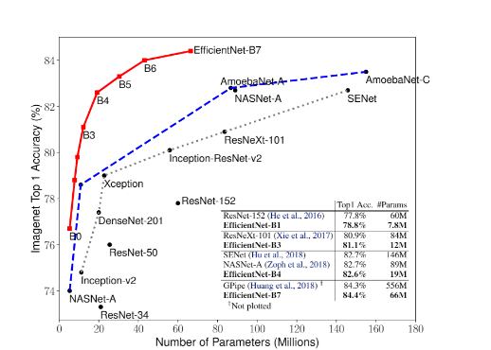coefficient on the remaining models. ConvNets that use EfficientNet models that are scaled appropriately perform more accurately than other types of ConvNets. Computational costs are much lesser for these EfficientNet models. The accuracy is very high for these models using much lesser parameters and FLOPS.

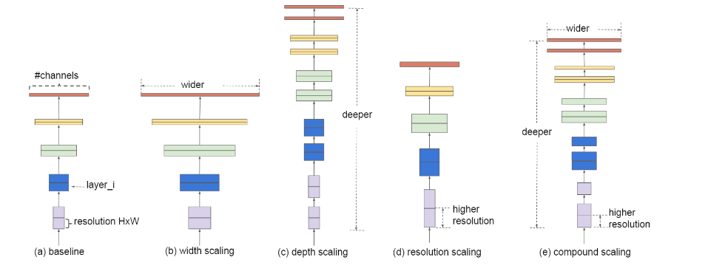

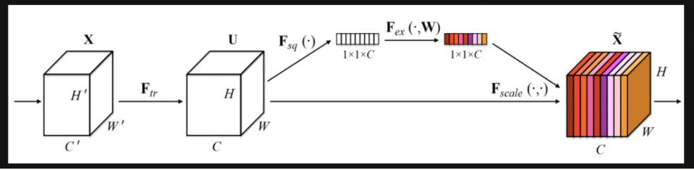

We propose EODNet : Efficient ODE Net and its subsequent architecture.

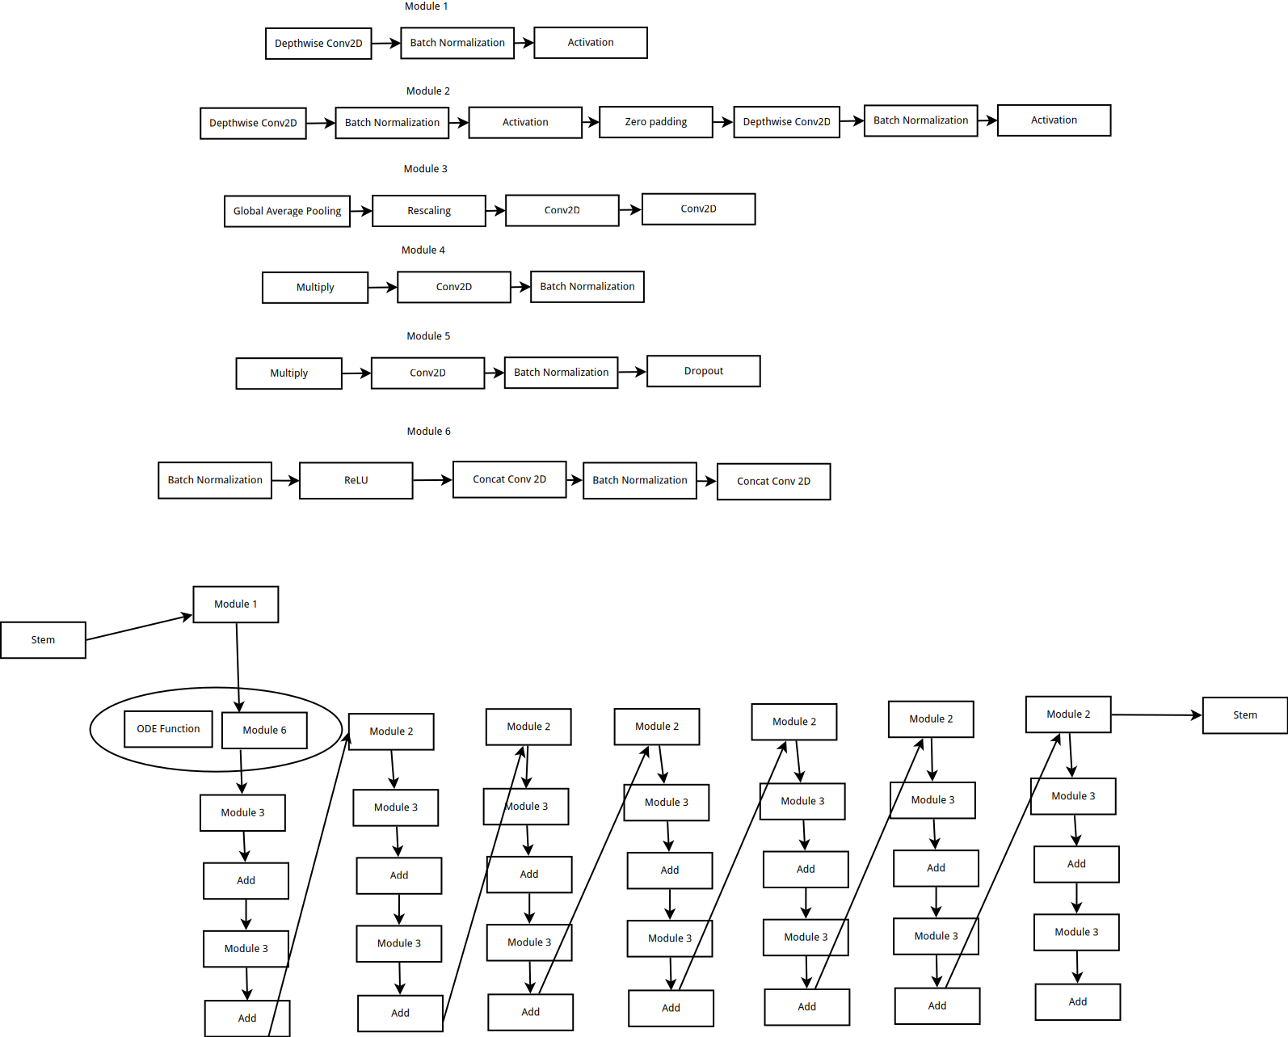

The framework for the system is built on a Python library called Pytorch. It is a deep learning library that is flexible and easy to work with. A separate trainer called pytorch lightning is also used, which would enable multi GPU support etc.

Since this is a neural network, the deep learning architecture that is used is a custom one. The backbone of efficient net b5 is combined with a neural ODE. This is a new architecture and has not been found in the literature previously.

The datasets that we have used are ASL recognition, Boat type recognition dataset, Flower type recognition dataset and for detecting fruits dataset.

4.2 CODES AND STANDARDS

For the purpose of our project and implementation of our code, we have adopted the python code standard of pep8.The main aim of using pep8 is to improve scalability and readability of our project for users. It also allows code to compile faster and is important for efficient use. The styling framework and set of guidelines are constantly evolving over a period of time and new set o rules are being introduced to improve performance and readability. There are different types of code layout which are important for following the pep8 coding standard.

For the purpose of indentation, the user must use four spaces per level of indentation. Elements of code that are wrapped vertically must be aligned next to the continuation lines.

While coding it is important to note that there should be no args on the initial line and then proper indentation should be done to differentiate the other continuation lines.

Spaces are used by the code standard for proper indentation. Users can use tabs when indentation takes place with only tabs. While writing code, every line can contain a maximum of 79 characters. In the case of comments, the lines can have a length of 72 characters. The editor can have a specific window width which makes for efficient review of code. In case long lines are needed in the code it can be done so parenthesizing expressions over several lines.

For naming conventions, a set of rules need to be followed as well. For naming functions, only lower-case words can be used. It is recommended to separate words using underscores to enhance the readability of the code. For naming variables, users can use lowercase letters and words. For naming classes, users should start each word with a capital letter which is called Camel Case. For methods, lowercase words are used. For modules and packages, short lowercase words are used.

For better layout of the code, some guidelines are to be followed for better readability.

The top-level functions as well as classes must be bordered with two blank lines. When users define a method inside a class, they must be bordered with a single blank. Users can also put blank lines while writing a function logic to help users understand the code better and improve readability.

4.3 CONSTRAINTS, ALTERNATIVES AND TRADEOFFS

Future directions of research would involve trying to dig deeper into the network using visualization of gradients to see if it could be improved. More datasets could also be tested and for much longer. Due to constraints on resources, this was currently not possible.

It would be of further use if a larger dataset such as imagenet could be tested eventually to have some more comprehensive results.

The constraints are that there were not enough resources to train deep models.So the tradeoff was made due to resource constraints. Grid search could be used to train large scale models and it cannot be used as there are not enough resources.

6 PROJECT DEMONSTRATION AND CODE

6.1 CODE

**1) We first import all the required libraries**

import matplotlib.pyplot as plt

import pandas as pd

import os

import glob

import cv2

import json

from collections import Counter

import pickle

import numpy as np

from efficientnet_pytorch import EfficientNet

import torch.optim as optim

import torch

from torch import nn

from torch.utils.data import DataLoader, random_split

from torch.nn import functional as F

from torch.utils.data import Dataset, TensorDataset, DataLoader

from torch.utils.tensorboard import SummaryWriter

import torchvision

from torchvision.datasets import ImageFolder

from torchvision import datasets, transforms

from torchdiffeq import odeint

import pytorch_lightning as pl

from pytorch_lightning import Trainer

from pytorch_lightning.loggers import CSVLogger, TensorBoardLogger

from pytorch_lightning.metrics.functional import accuracy

from pytorch_lightning.callbacks.early_stopping import EarlyStopping

import albumentations as A

from albumentations.core.composition import Compose

from albumentations.pytorch import ToTensorV2

from sklearn import metrics, model_selection,preprocessing

from sklearn.model_selection import StratifiedKFold

from sklearn.metrics import confusion_matrix

**2) Creating the model**

def conv3x3(in_planes, out_planes, stride=1):

return nn.Conv2d(in_planes, out_planes, kernel_size=3, stride=stride, padding=1, bias=False)

def conv1x1(in_planes, out_planes, stride=1):

return nn.Conv2d(in_planes, out_planes, kernel_size=1, stride=stride, bias=False)

def norm(dim):

return nn.GroupNorm(min(32, dim), dim)

class ResBlock(nn.Module):

expansion = 1

def __init__(self, inplanes, planes, stride=1, downsample=None):

super(ResBlock, self).__init__()

self.norm1 = norm(inplanes)

self.relu = nn.ReLU(inplace=True)

self.downsample = downsample

self.conv1 = conv3x3(inplanes, planes, stride)

self.norm2 = norm(planes)

self.conv2 = conv3x3(planes, planes)

def forward(self, x):

shortcut = x

out = self.relu(self.norm1(x))

if self.downsample is not None:

shortcut = self.downsample(out)

out = self.conv1(out)

out = self.norm2(out)

out = self.relu(out)

out = self.conv2(out)

return out + shortcut

class ConcatConv2d(nn.Module):

def __init__(self, dim_in, dim_out, ksize=3, stride=1, padding=0, dilation=1, groups=1, bias=True, transpose=False):

super(ConcatConv2d, self).__init__()

module = nn.ConvTranspose2d if transpose else nn.Conv2d

self._layer = module(

dim_in + 1, dim_out, kernel_size=ksize, stride=stride, padding=padding, dilation=dilation, groups=groups,

bias=bias

)

def forward(self, t, x):

tt = torch.ones_like(x[:, :1, :, :]) * t

ttx = torch.cat([tt, x], 1)

return self._layer(ttx)

class ODEfunc(nn.Module):

def __init__(self, dim):

super(ODEfunc, self).__init__()

self.norm1 = norm(dim)

self.relu = nn.ReLU(inplace=True)

self.conv1 = ConcatConv2d(dim, dim, 3, 1, 1)

self.norm2 = norm(dim)

self.conv2 = ConcatConv2d(dim, dim, 3, 1, 1)

self.norm3 = norm(dim)

self.nfe = 0

def forward(self, t, x):

self.nfe += 1

out = self.norm1(x)

out = self.relu(out)

out = self.conv1(t, out)

out = self.norm2(out)

out = self.relu(out)

out = self.conv2(t, out)

out = self.norm3(out)

return out

class ODEBlock(nn.Module):

def __init__(self, odefunc):

super(ODEBlock, self).__init__()

self.odefunc = odefunc

self.integration_time = torch.tensor([0, 1]).float()

def forward(self, oui):

self.integration_time = self.integration_time.type_as(oui)

out = odeint(self.odefunc, oui, self.integration_time, rtol=1e-3, atol=1e-3)

return torch.cuda.FloatTensor(oui)

@property

def nfe(self):

return self.odefunc.nfe

@nfe.setter

def nfe(self, value):

self.odefunc.nfe = value

class Flatten(nn.Module):

def __init__(self):

super(Flatten, self).__init__()

def forward(self, x):

shape = torch.prod(torch.tensor(x.shape[1:])).item()

return x.view(-1, shape)

**3) Defining the Dataloader, Optimizer and Loss function**

class LitModel(pl.LightningModule):

def __init__(self, num_classes, learning_rate=1e-4, weight_decay=0.0001):

super().__init__()

# log hyperparameters

self.save_hyperparameters()

self.num_classes = num_classes

self.learning_rate = learning_rate

self.weight_decay = weight_decay

self.enet = EfficientNet.from_pretrained('efficientnet-b5',num_classes=self.num_classes)

self.enet._bn1 = nn.Sequential(

ODEBlock(ODEfunc(2048)),

nn.BatchNorm2d(2048, eps=0.001, momentum=0.010000000000000009, affine=True, track_running_stats=True),

)

in_features = self.enet._fc.in_features

self.enet._fc = nn.Linear(in_features, num_classes)

# @sn.snoop()

def forward(self, x):

out = self.enet(torch.cuda.FloatTensor(x))

return out

def configure_optimizers(self):

optimizer = torch.optim.AdamW(self.parameters(),

lr=self.learning_rate,

weight_decay=self.weight_decay)

scheduler = torch.optim.lr_scheduler.StepLR(optimizer,

step_size=2,

gamma=0.1)

return ([optimizer], [scheduler])

def training_step(self, train_batch, batch_idx):

x, y = train_batch["x"], train_batch["y"]

x =x.type(torch.cuda.FloatTensor)

preds = self(x)

loss = F.cross_entropy(preds, y)

# loss.requires_grad = True

acc = accuracy(preds, y)

self.log('train_acc_step', acc)

self.log('train_loss', loss)

return loss

def validation_step(self, val_batch, batch_idx):

x, y = val_batch["x"], val_batch["y"]

x =x.type(torch.cuda.FloatTensor)

preds = self(x)

loss = F.cross_entropy(preds, y)

# loss.requires_grad = True

acc = accuracy(preds, y)

self.log('val_acc_step', acc)

self.log('val_loss', loss)

# print(preds.detach().cpu(), y.detach().cpu())

y2 = torch.argmax(preds, dim = 1)

conf = confusion_matrix(y2.detach().cpu(), y.detach().cpu())

fig = plt.figure()

plt.imshow(conf)

# plt.show()

self.logger.experiment.add_figure("Confusion matrix", fig, self.current_epoch)

**4) Defining the dataset loader**

class ImageClassDs(Dataset):

def __init__(self,

df: pd.DataFrame,

imfolder: str,

train: bool = True,

transforms=None):

self.df = df

self.imfolder = imfolder

self.train = train

self.transforms = transforms

def __getitem__(self, index):

im_path = self.df.iloc[index]['image_id']

x = cv2.imread(im_path, cv2.IMREAD_COLOR)

x = cv2.cvtColor(x, cv2.COLOR_BGR2RGB)

if (self.transforms):

x = self.transforms(image=x)['image']

y = self.df.iloc[index]['label']

return {

"x": x,

"y": y,

}

def __len__(self):

return len(self.df)

**5) Loading Data**

class ImDataModule(pl.LightningDataModule):

def __init__(

self,

df,

batch_size,

num_classes,

data_dir: str = "/media/hdd/Datasets/fruits/fruits-360/Training/",

img_size=(256, 256)):

super().__init__()

self.df = df

self.data_dir = data_dir

self.batch_size = batch_size

self.train_transform = A.Compose([

A.RandomResizedCrop(img_size, img_size, p=1.0),

ToTensorV2(p=1.0),

],

p=1.)

self.valid_transform = A.Compose([

A.CenterCrop(img_size, img_size, p=1.),

A.Resize(img_size, img_size),

A.Normalize(mean=[0.485, 0.456, 0.406],

std=[0.229, 0.224, 0.225],

max_pixel_value=255.0,

p=1.0),

ToTensorV2(p=1.0),

],

p=1.)

def setup(self, stage=None):

dfx = pd.read_csv("./train_folds.csv")

train = dfx.loc[dfx["kfold"] != 1]

val = dfx.loc[dfx["kfold"] == 1]

self.train_dataset = ImageClassDs(train,

self.data_dir,

train=True,

transforms=self.train_transform)

self.valid_dataset = ImageClassDs(val,

self.data_dir,

train=False,

transforms=self.valid_transform)

def train_dataloader(self):

return DataLoader(self.train_dataset,

batch_size=self.batch_size,

num_workers=12,

shuffle=True)

def val_dataloader(self):

return DataLoader(self.valid_dataset,

batch_size=self.batch_size,

num_workers=12)

**6) Initializing all the required functions**

batch_size = 128

num_classes = 131

img_size = 64

dm = ImDataModule(df,

batch_size=batch_size,

num_classes=num_classes,

img_size=img_size)

class_ids = dm.setup()

model = LitModel(num_classes);

logger = TensorBoardLogger("logs/", name = "default")

trainer = pl.Trainer(auto_select_gpus=True,

gpus=1,

# precision=16,

profiler=False,

max_epochs=2,

callbacks=[pl.callbacks.ProgressBar()],

logger=logger)

**7 ) Fitting**

trainer.fit(model, dm)

trainer.test()

trainer.save_checkpoint('model1_fruits.ckpt')

**8) Loading data for and similarly for the other datasets**

main_path = "/media/hdd/Datasets/asl/asl_alphabet_train/"

all_ims = glob.glob(main_path+"/*/*.jpg");all_ims[0]

len(all_ims)

def create_label(x):

return x.split("/")[-2]

df = pd.DataFrame.from_dict({x:create_label(x) for x in all_ims} ,orient='index').reset_index()

df.columns = ["image_id","label"]

df.head()

df_b = df

df.label.unique()

df.label.nunique()

temp = preprocessing.LabelEncoder()

df['label'] = temp.fit_transform(df.label.values)

label_map= {i: l for i, l in enumerate(temp.classes_)}

df.label.nunique()

df.label.value_counts()

df["kfold"] = -1

df = df.sample(frac=1).reset_index(drop=True)

stratify = StratifiedKFold(n_splits=5)

for i, (t_idx, v_idx) in enumerate(

stratify.split(X=df.image_id.values, y=df.label.values)):

df.loc[v_idx, "kfold"] = i

df.to_csv("train_folds_fruits.csv", index=False)

pd.read_csv("train_folds_fruits.csv").head(1)

6.2) Results and Analysis

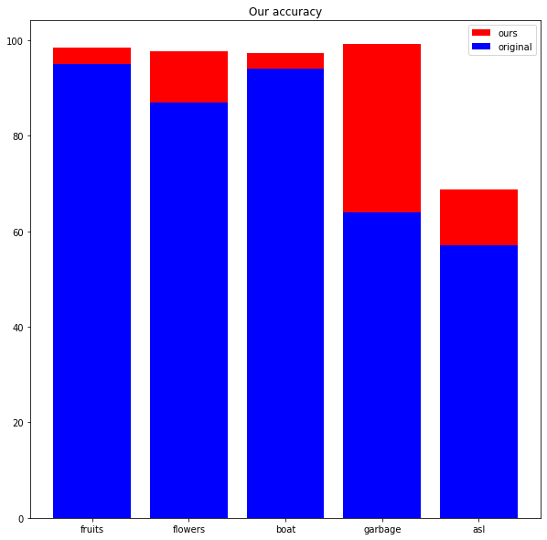

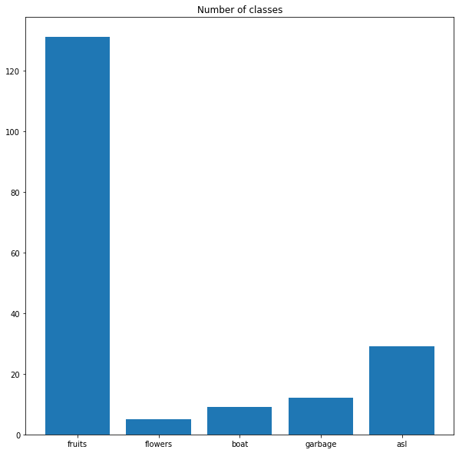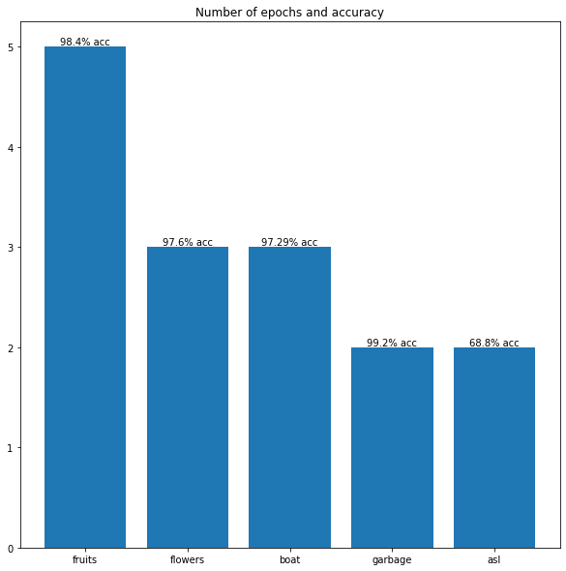

1) ASL

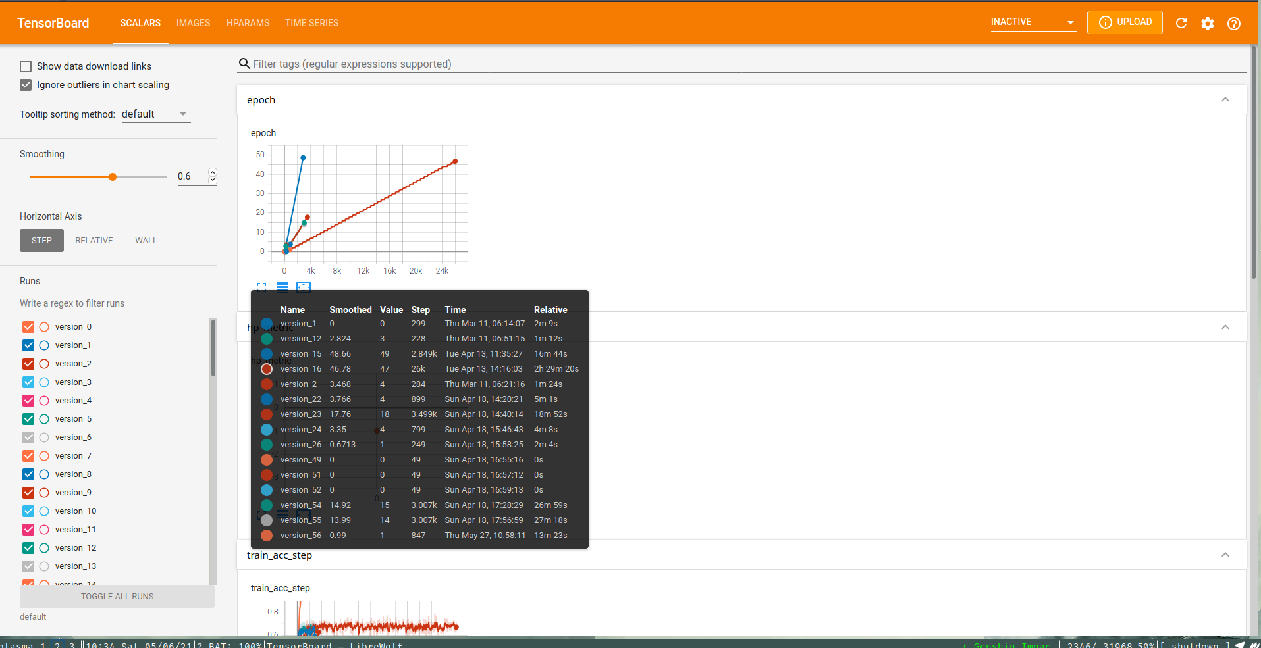  
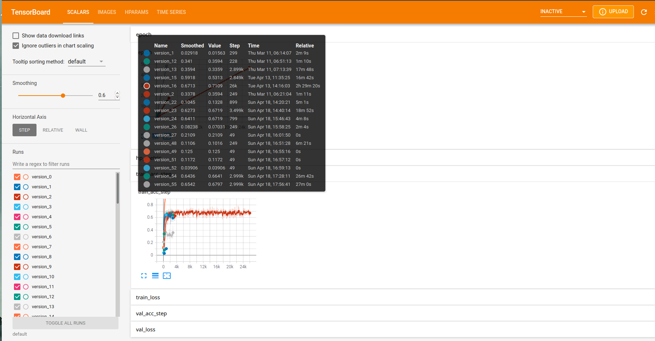

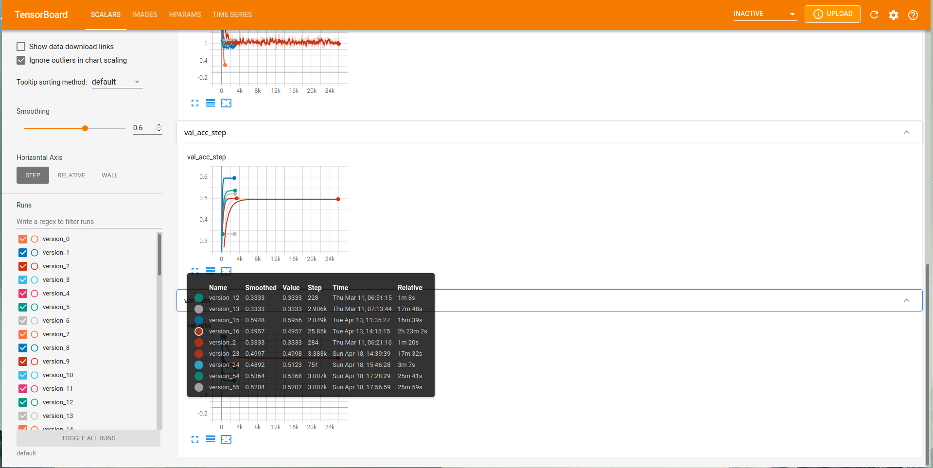

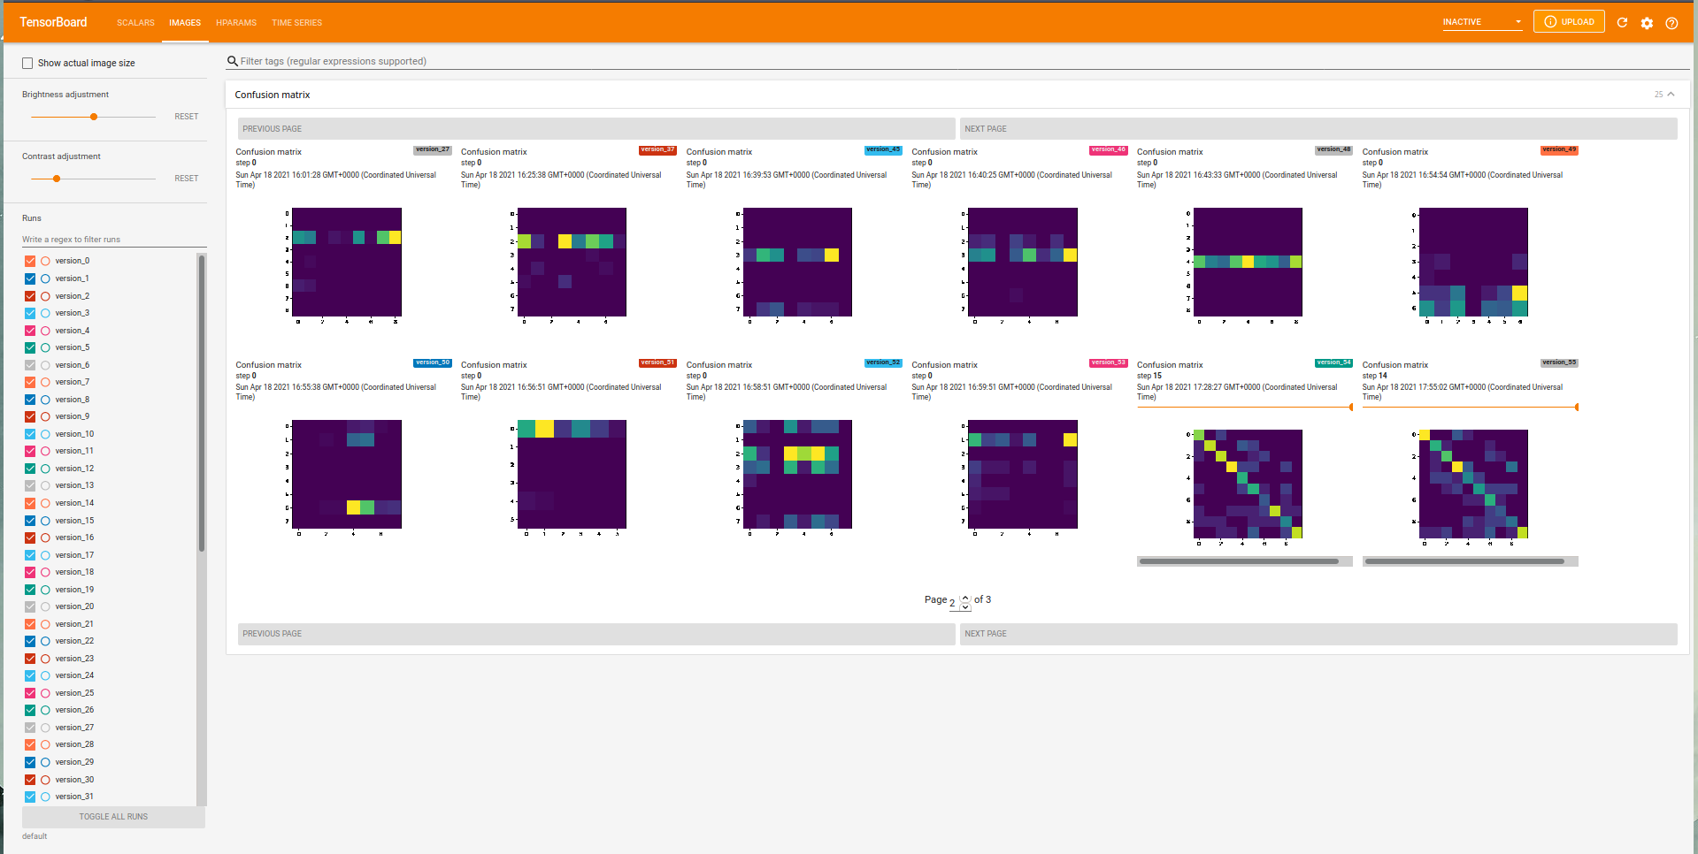

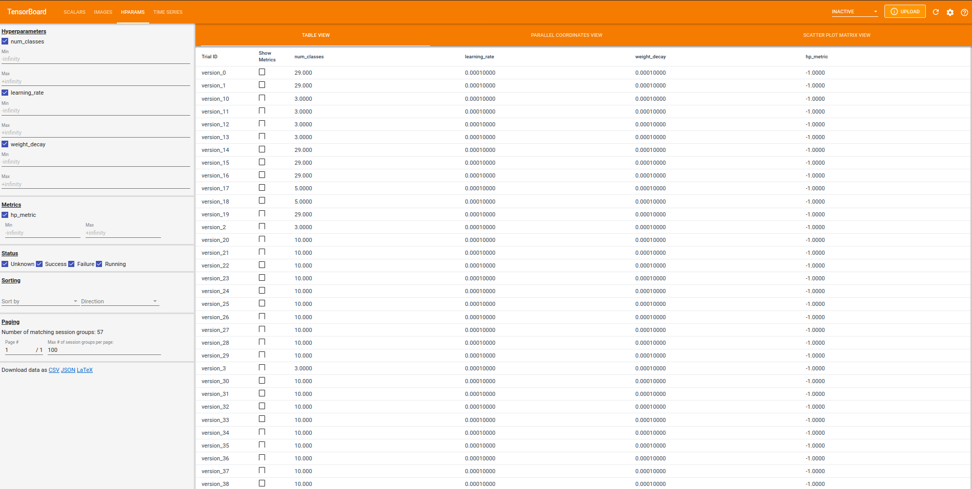  
  
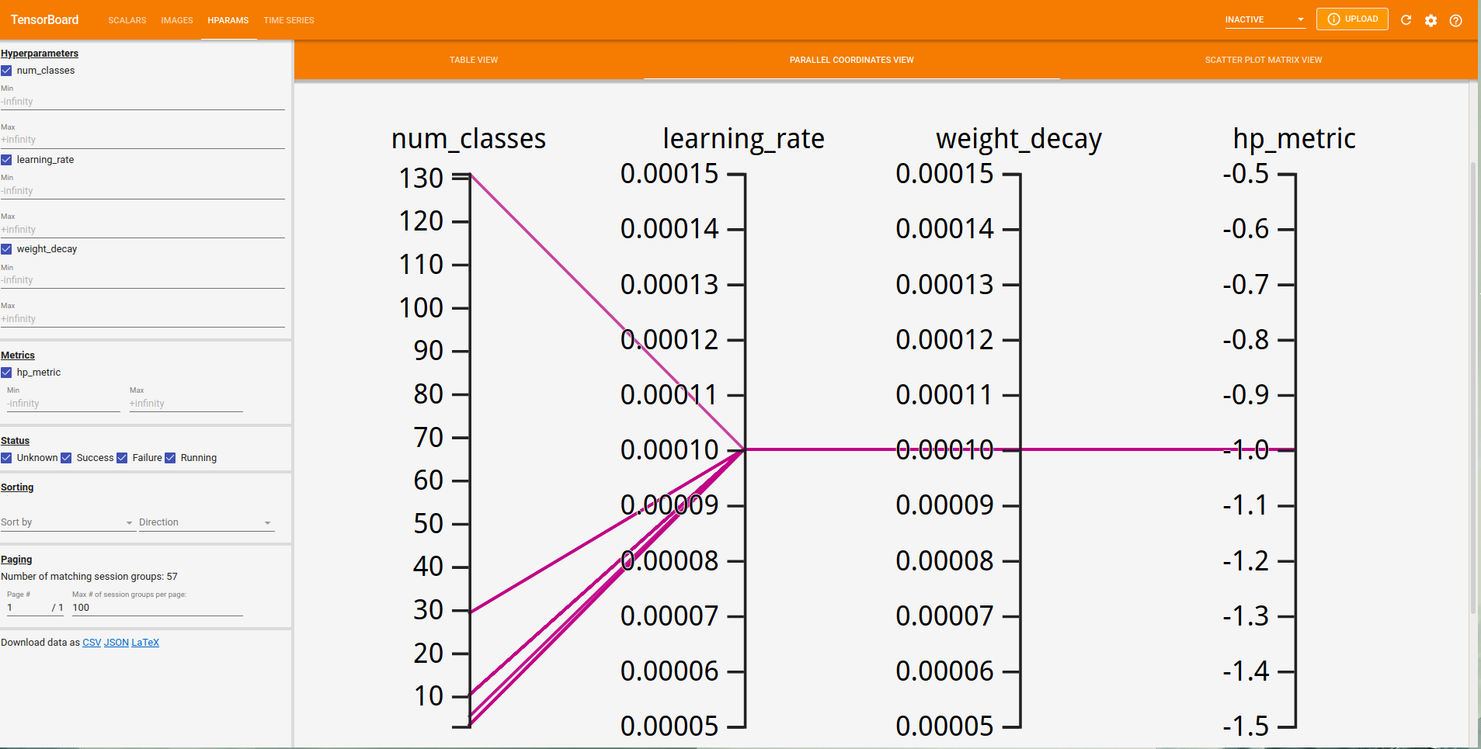

2) BOATS

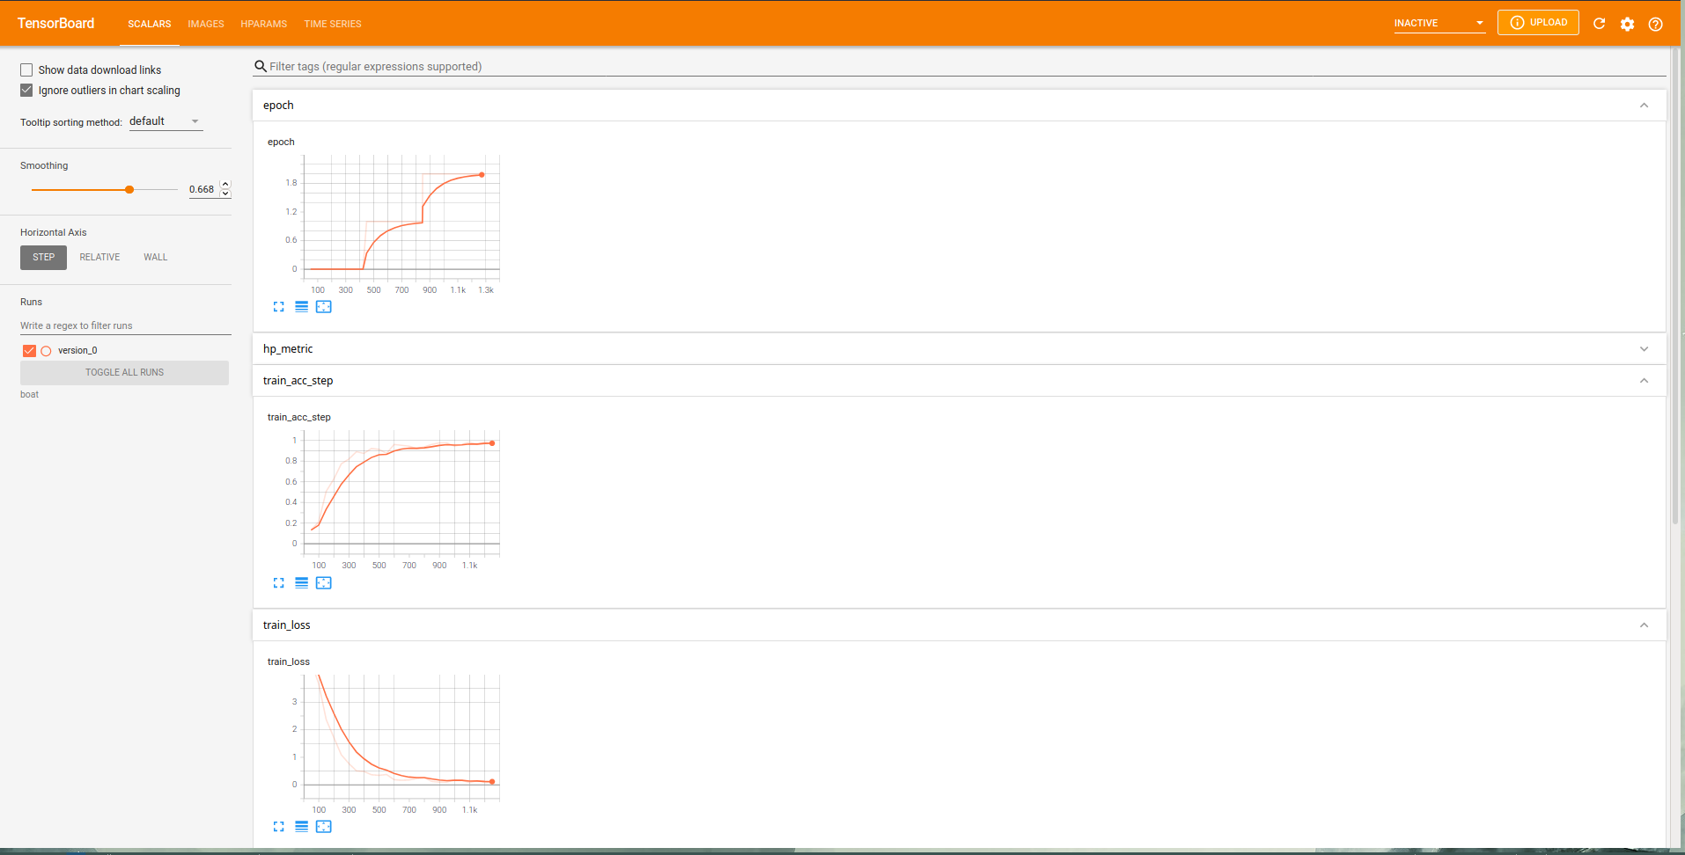

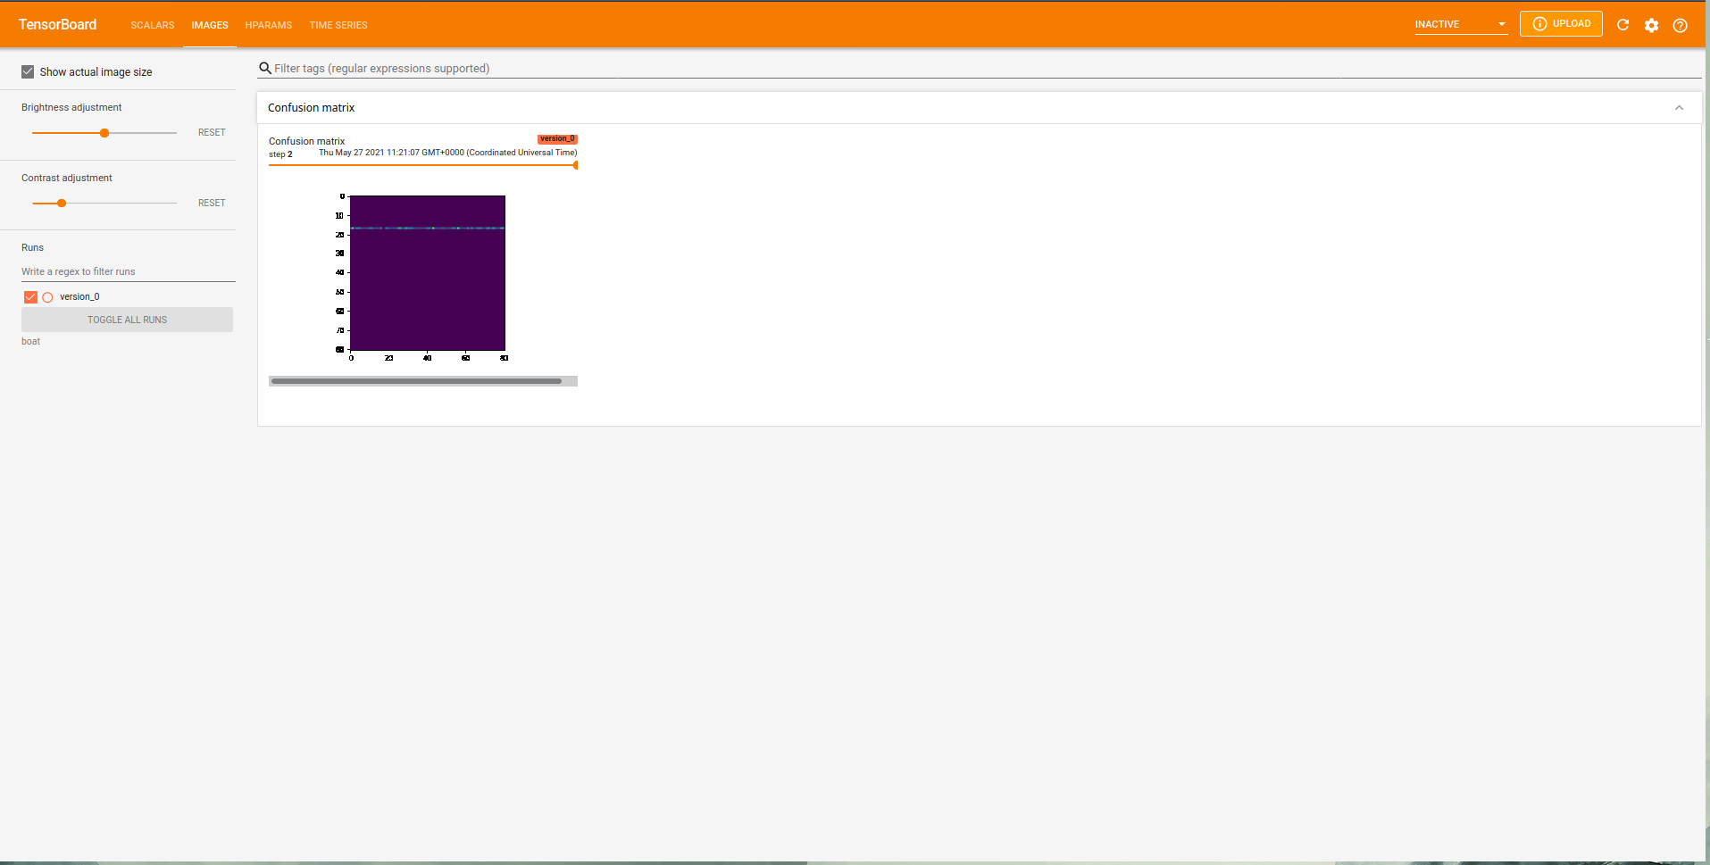

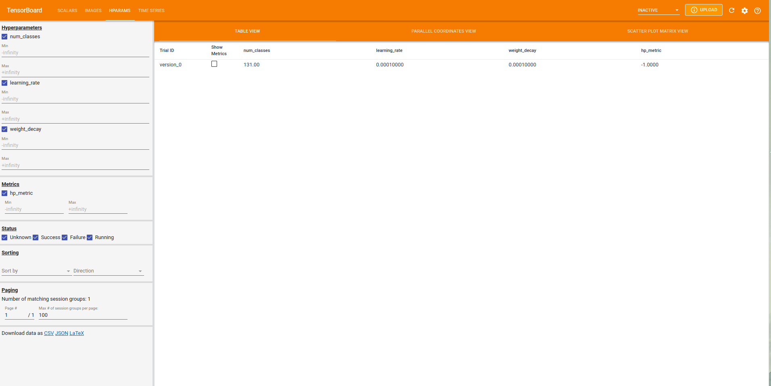  
  
  
  
  
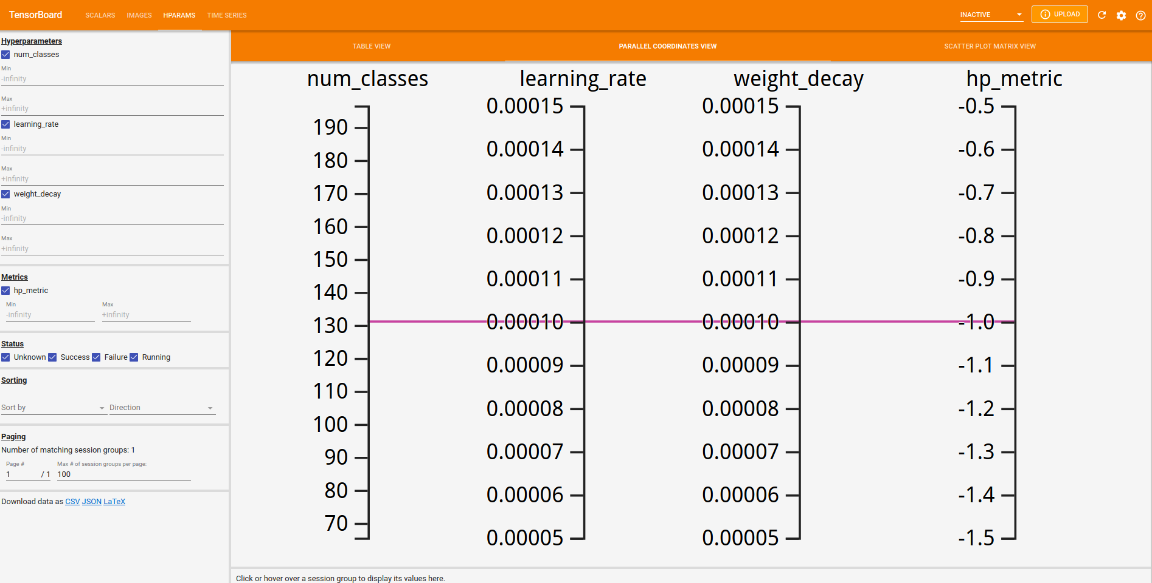

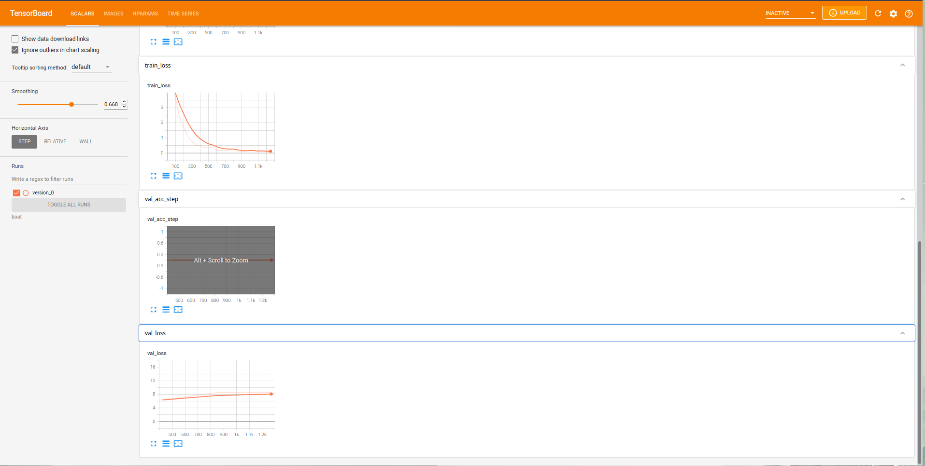

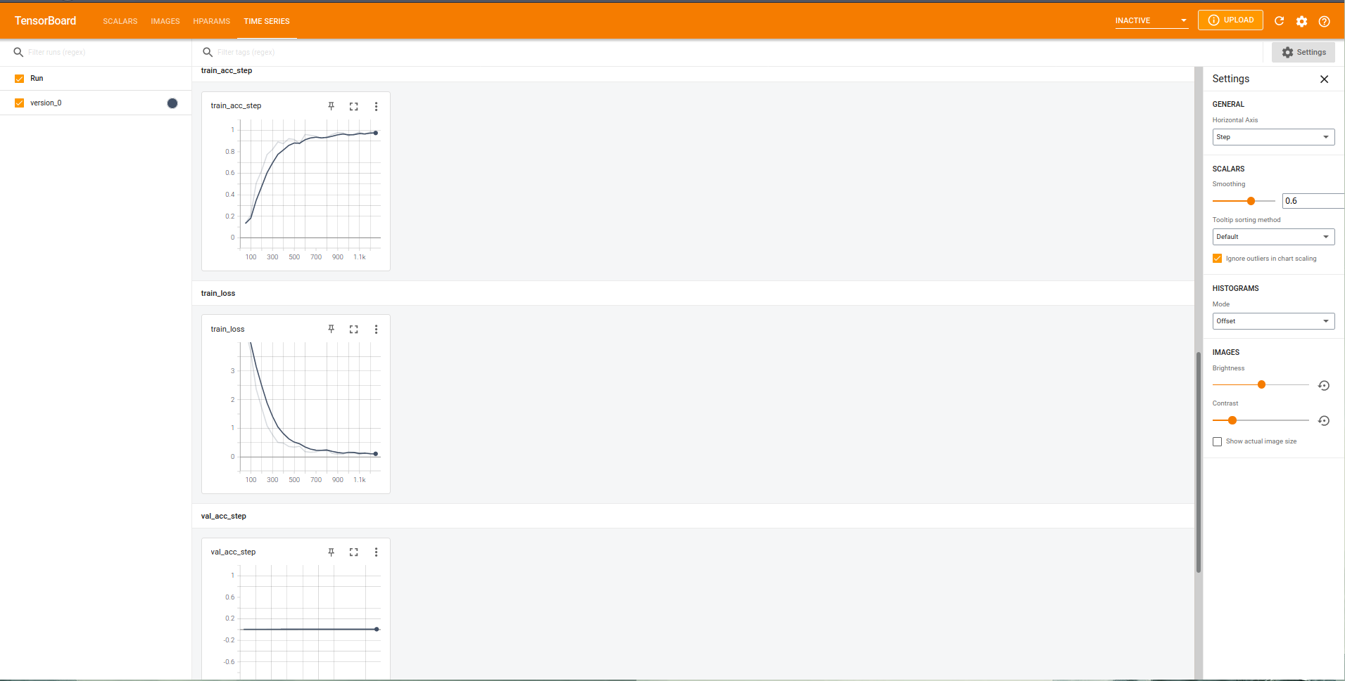

3) FLOWERS

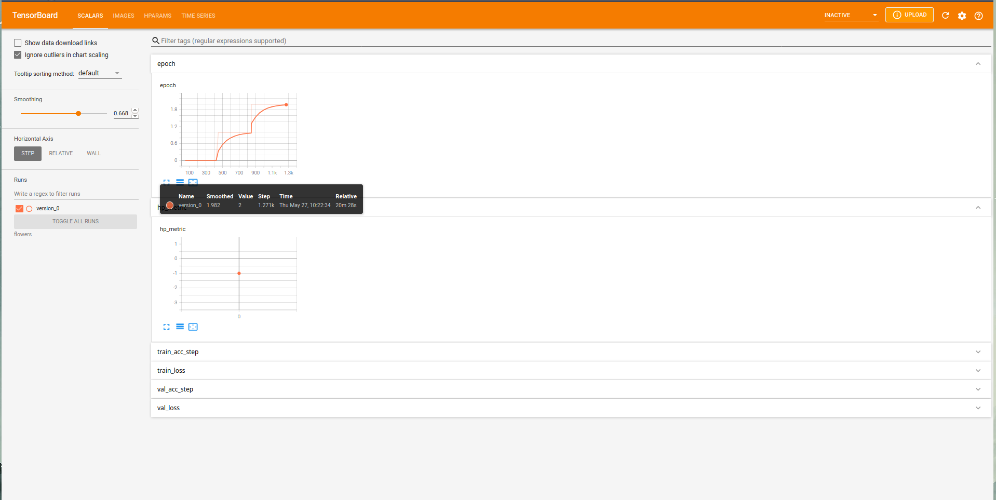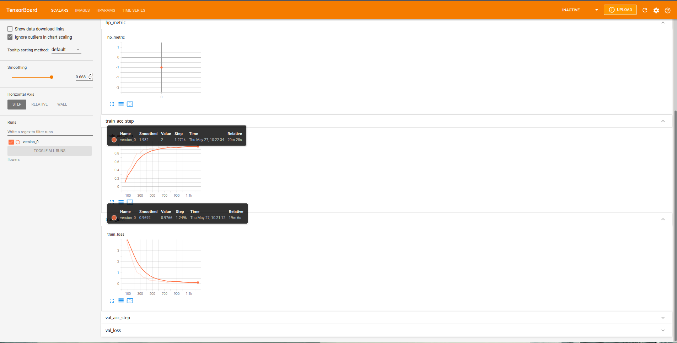

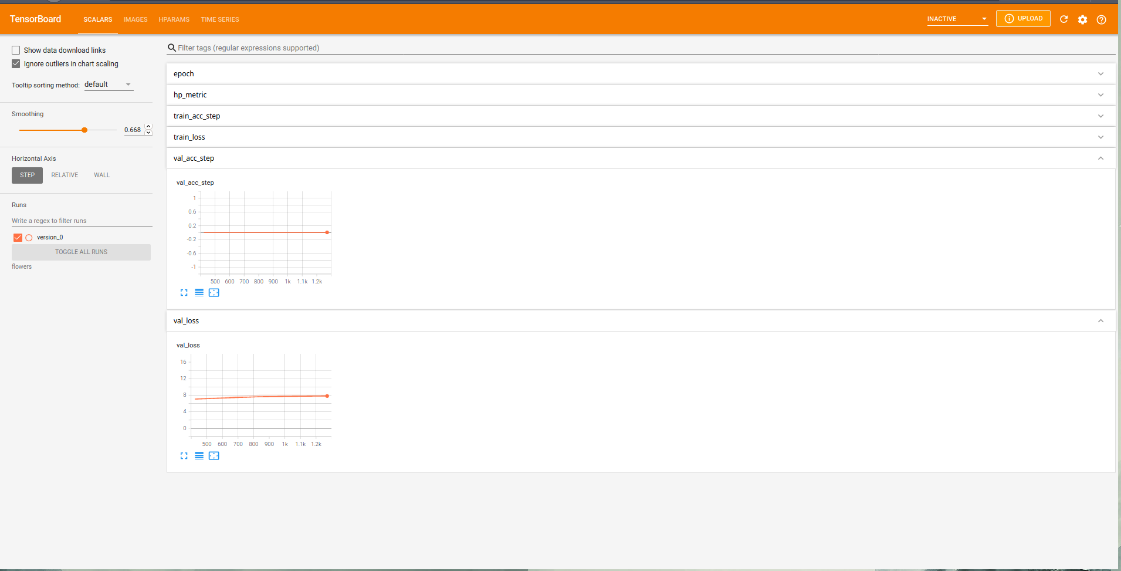  
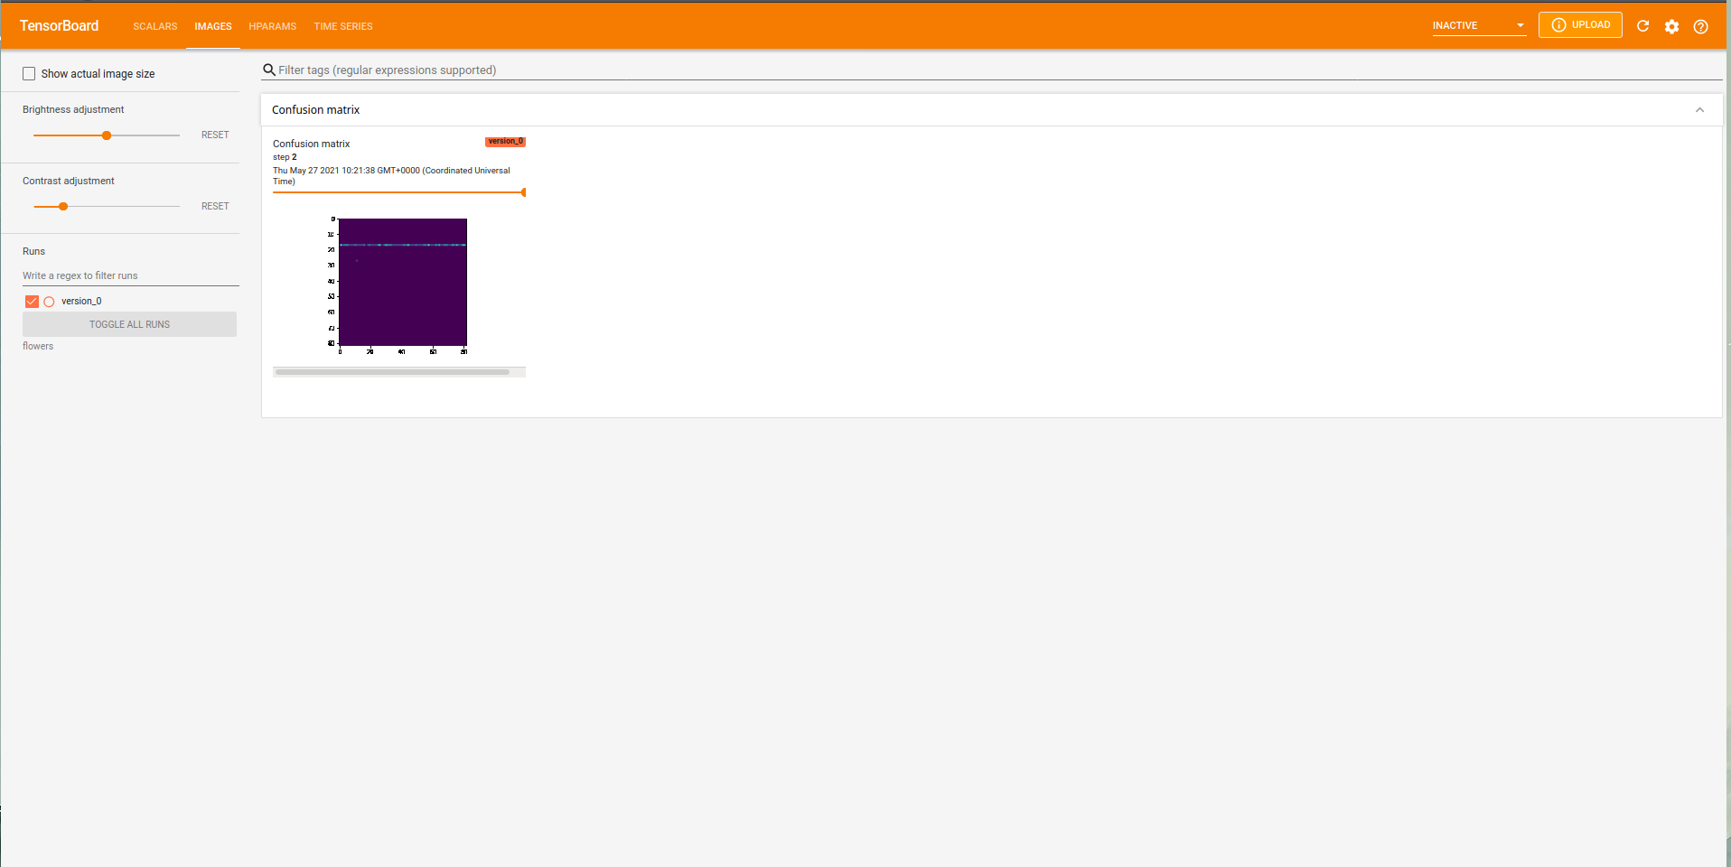

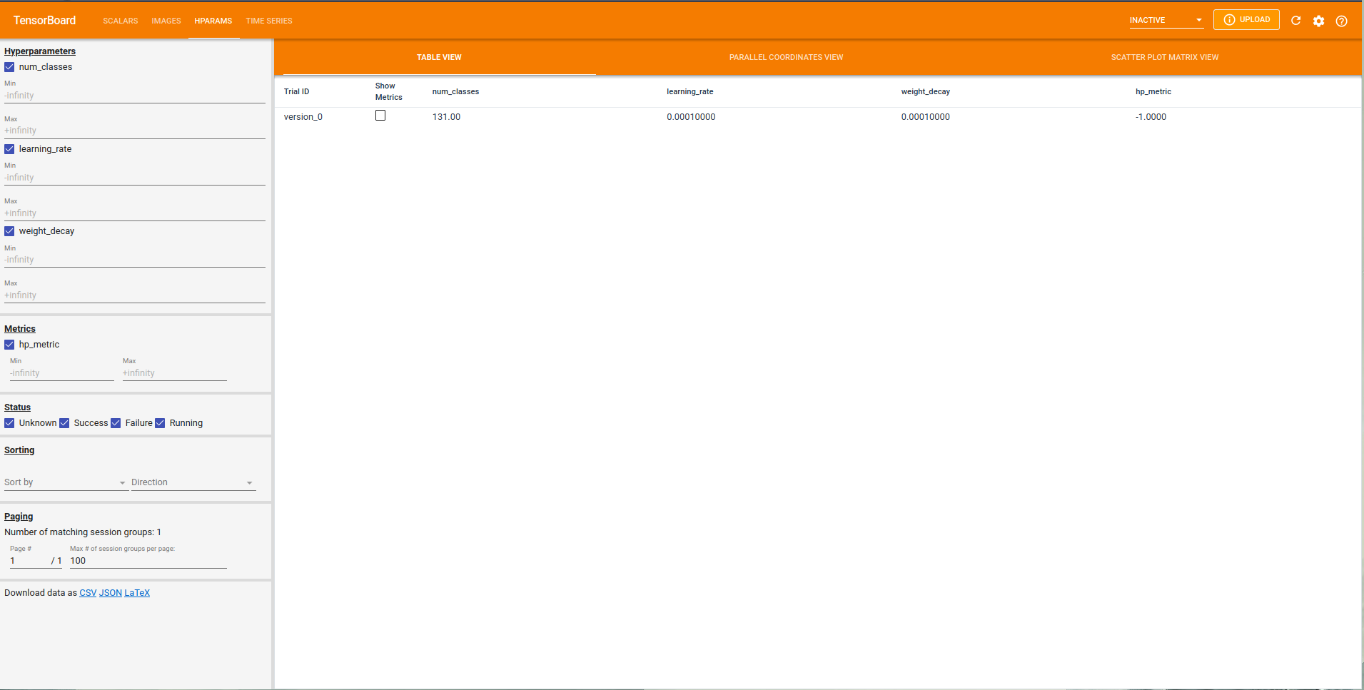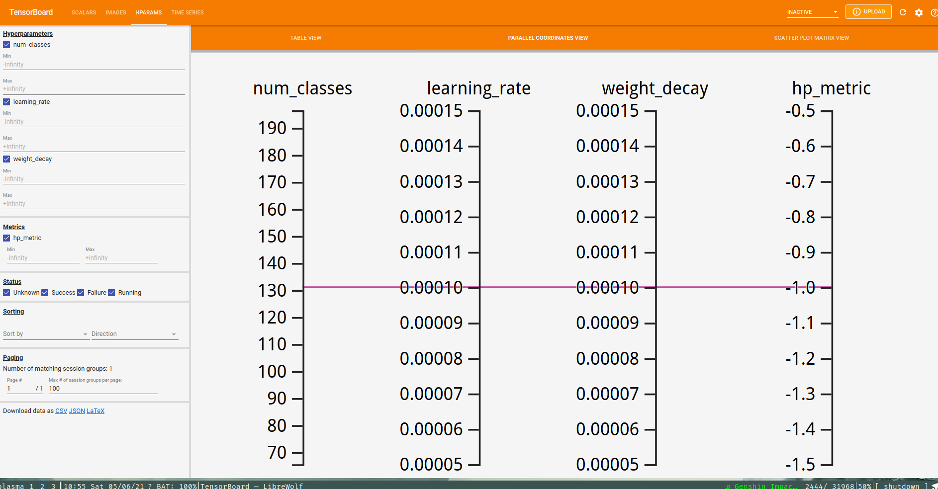

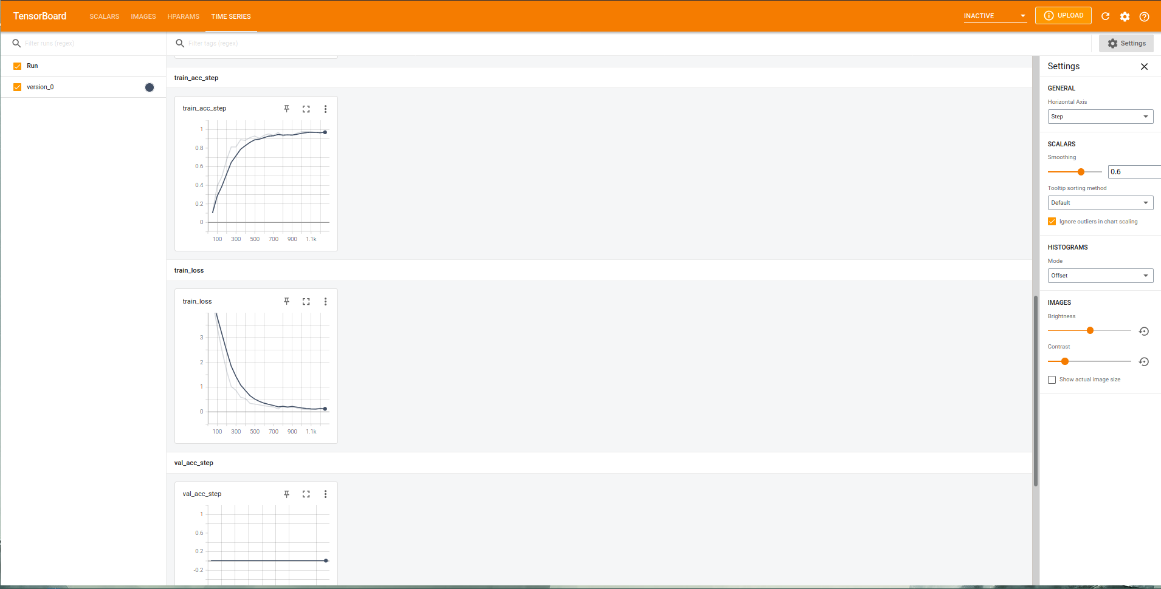  
  
FRUITS

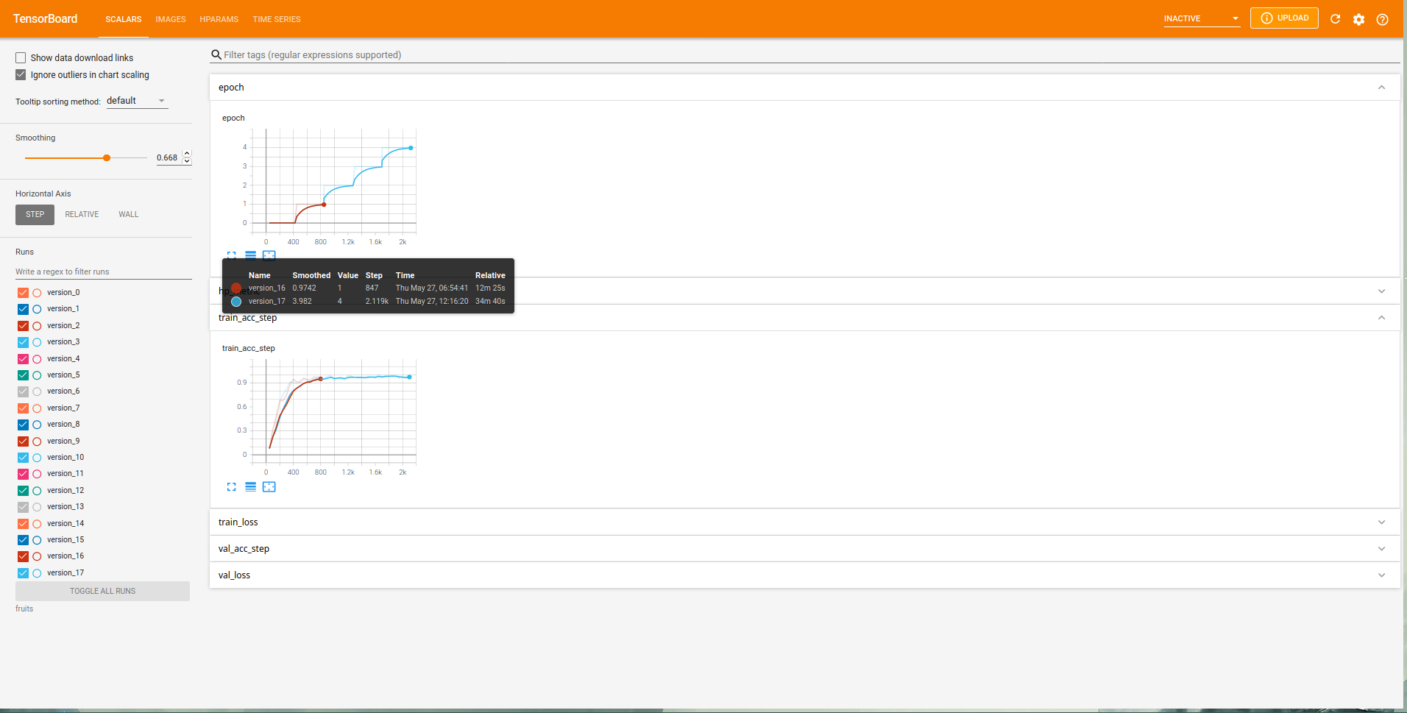

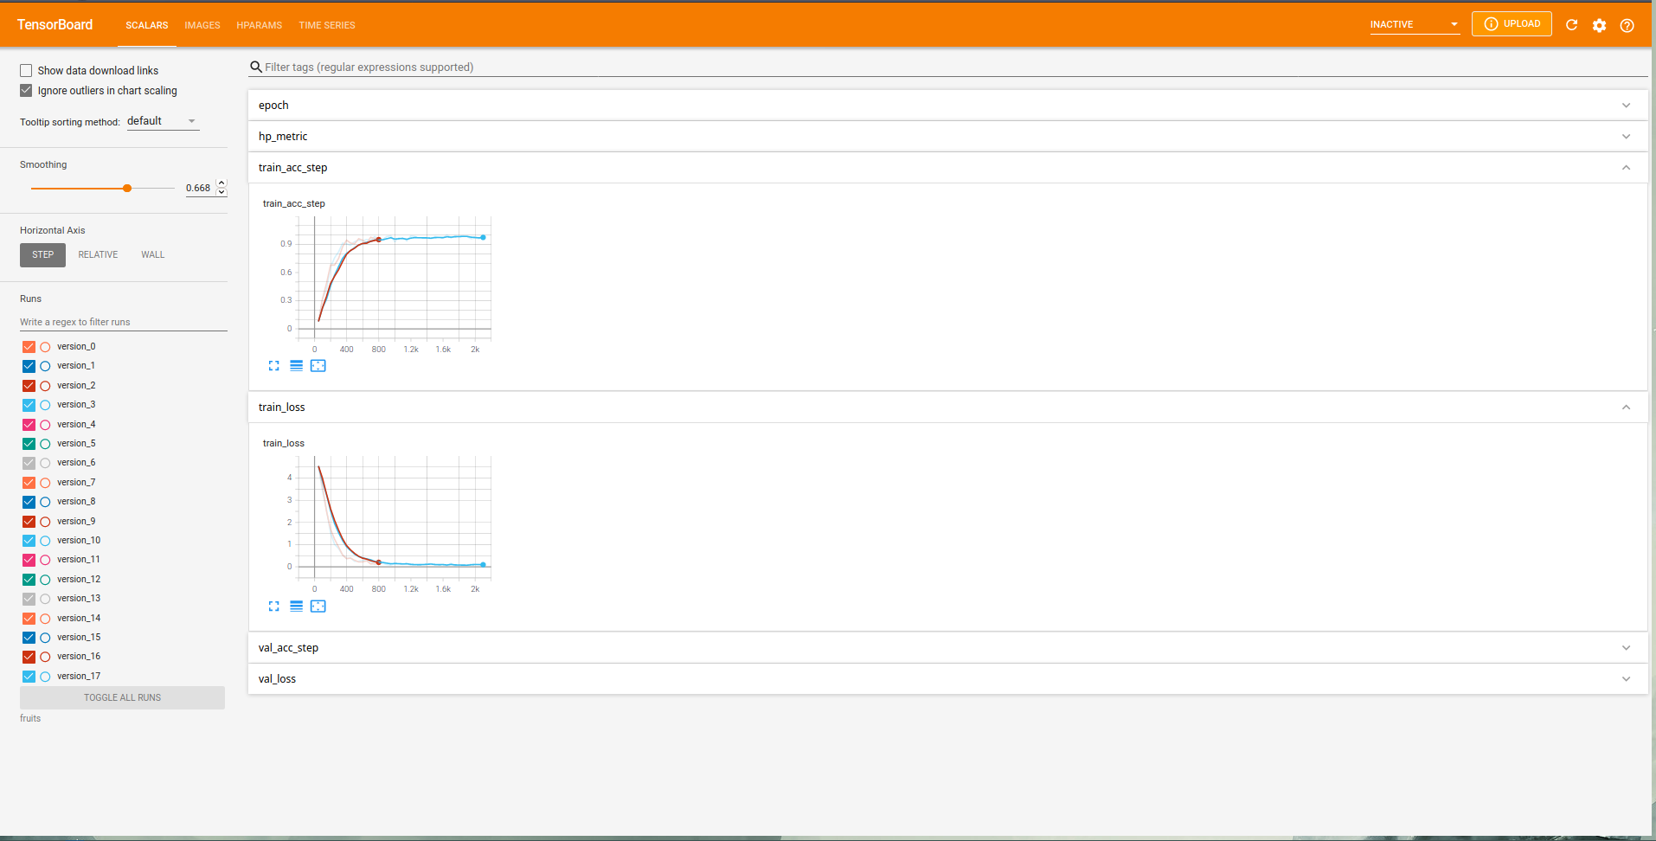  
  
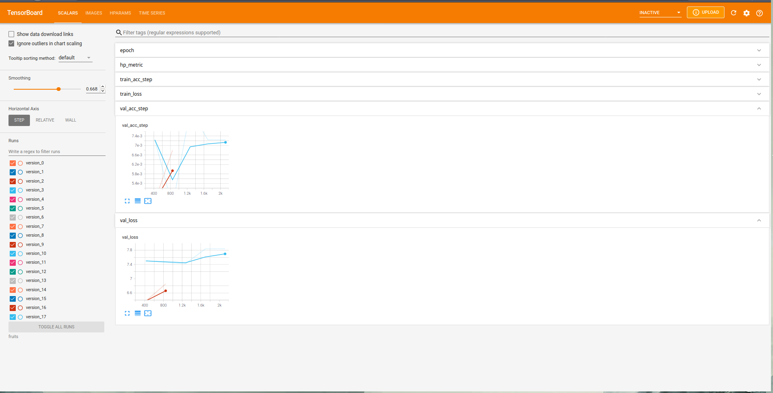

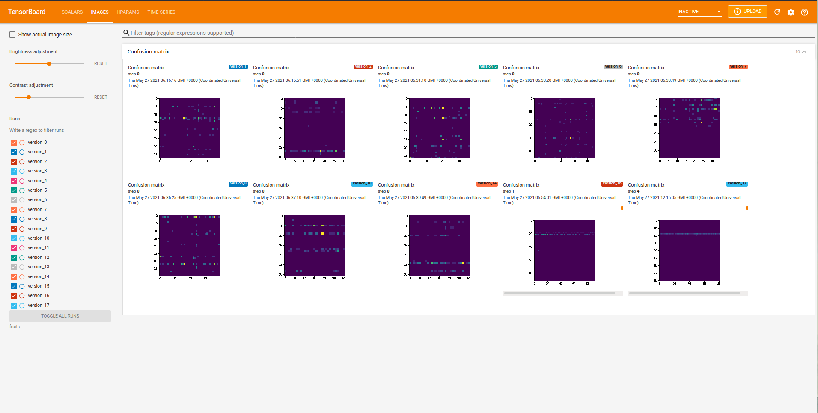  
  
  
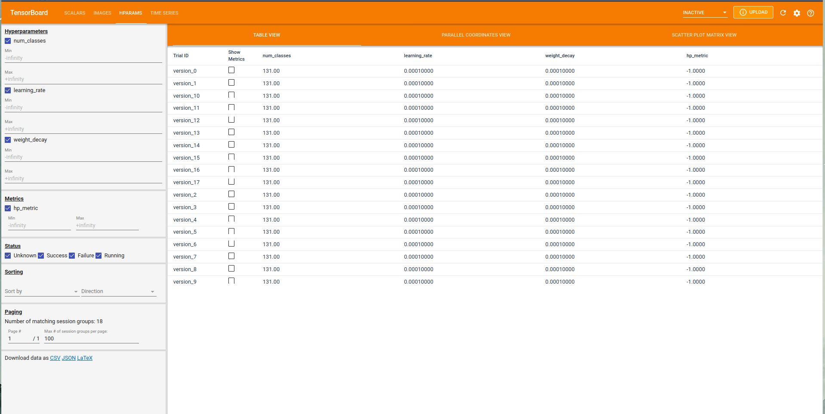

GARBAGE

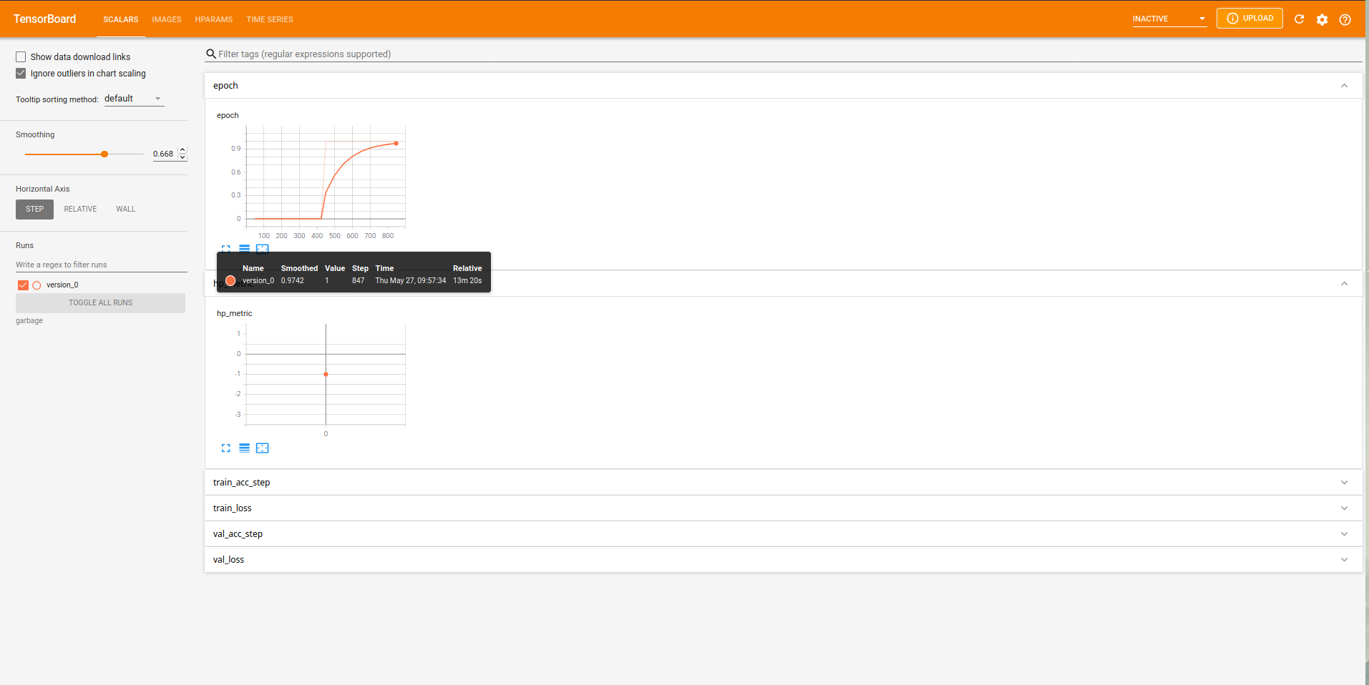  
  
  
  
  
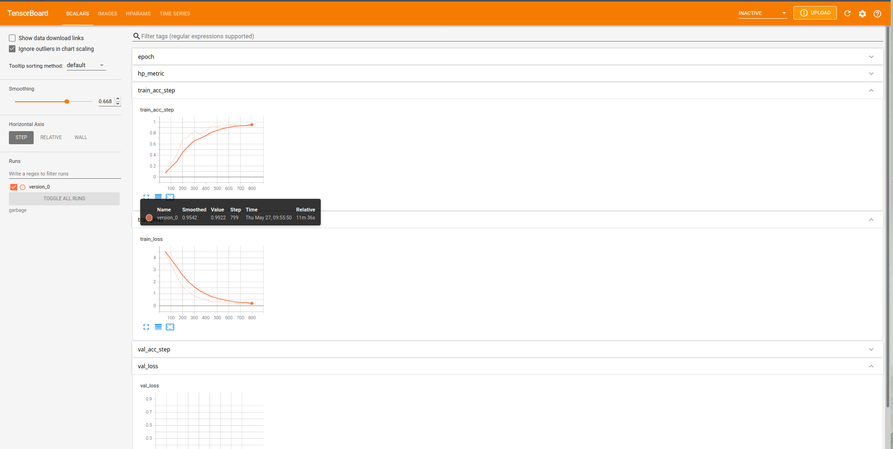

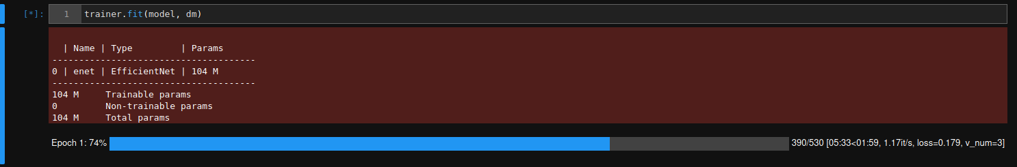

## References

1. Rackauckas, C., Ma, Y., Martensen, J., Warner, C., Zubov, K., Supekar, R., ... & Ramadhan, A. (2020). Universal differential equations for scientific machine learning. arXiv preprint arXiv:2001.04385.
2. Filici, C. (2008). On a neural approximator to ODEs. IEEE transactions on neural networks, 19(3), 539-543.
3. Jianyu, L., Siwei, L., Yingjian, Q., & Yaping, H. (2003). Numerical solution of elliptic partial differential equation using radial basis function neural networks. Neural Networks, 16(5-6), 729-734.
4. Massaroli, S., Poli, M., Park, J., Yamashita, A., & Asama, H. (2020). Dissecting neural odes. arXiv preprint arXiv:2002.08071.
5. Avelin, B., & Nyström, K. (2019). Neural ODEs as the deep limit of ResNets with constant weights. arXiv preprint arXiv:1906.12183.
6. Chen, R. T., Rubanova, Y., Bettencourt, J., & Duvenaud, D. (2018). Neural ordinary differential equations. arXiv preprint arXiv:1806.07366.
7. Zhang, H., Gao, X., Unterman, J., & Arodz, T. (2020, November). Approximation capabilities of neural ODEs and invertible residual networks. In International Conference on Machine Learning (pp. 11086-11095). PMLR.
8. Massaroli, S., Poli, M., Bin, M., Park, J., Yamashita, A., & Asama, H. (2020). Stable neural flows. arXiv preprint arXiv:2003.08063.
9. Liu, Z., Yang, Y., & Cai, Q. (2019). Neural network as a function approximator and its application in solving differential equations. Applied Mathematics and Mechanics, 40(2), 237-248.
10. Rackauckas, C., Innes, M., Ma, Y., Bettencourt, J., White, L., & Dixit, V. (2019). Diffeqflux. jl-A julia library for neural differential equations. arXiv preprint arXiv:1902.02376